**A**

**PROJECT REPORT**

**ON**

**GRAIN TRANSPORT SYSTEM**

For

Performance Appraisal

**Submitted**

**By**

( BFTZ | Edwin Duan, Simon, Kevin, Lion )

( BFTZ| 段熙宇，汤显彪，朱思宇，李雨滋 )

段熙宇:R8J9400053

汤显彪:R8J9400044

朱思宇:R8J9400042

李雨滋:R8J9400056

Start Date 2019-05-13

End Date 2019-05-23

Code Instructor Teachers

Mr.Asho Mr.周晖

Mr.刘德才 Mr.王兆晖

Ou Yulong

NIIT-HNU

 



**PROJECT INDEX**

**TEAM DESCRIPTION AND OVERVIEW··········· 5**

**ACKNOWLEDGEMENT················· ·6**

**Introduction························7**

**Software Requirements···················7**

**SDLC of the Project·····················7**

**Requirement Analysis····················7**

**Development························8**

**Testing··························8**

**DEVELOPING USER LOGIN MODULE···········9**

**DEVELOPING USER REGISTRATION MODULE·······9**

**DEVELOPING PERSONAL CENTER MODULE（PCM）···10**

**DEVELOPING THE DELIVERY MODULE··········10**

**DEVELOPING PAYMENT MODULE·············10**

**DEVELOPING RECEIVING MODULE············10**

**DEVELOPING THE QUERY MODULE············11**

**DEVELOPING USER FEEDBACK MODULE·········11**

**DEVELOPING PUSH SERVICE MODULE···········11**

**Database Design·····················12-13**

**Use Case Diagram·····················14**

**DFD of Login module····················15**

**Requirements module DFD·················16**

**Data Flow Diagram·····················17**

**COST ESTIMATION····················18**

**Login Module·······················19**

**New User Registration Module················19**

**User name and password prompt Module··············20**

**User Interface Module···················40**

**User Personal Center Module················48**

**Leave the message for the company Module··········58**

**Send the goods Module（Ocean Transportation）·······61**

**Payment Module（Ocean Transportation）··········62**

**Get the order number for your goods（Ocean Transportation）·62**

**The BFTZ Company Invoice(Sea Transportation)·······63**

**Check your Order Forms Module··············87**

**Search the order by ID···················88**

**All the time goods GPS Location(Air Transportation)·····104**

**All the time goods GPS Location(Land Transportation)····104**

**All the time goods GPS Location(Sea Transportation)·····105**

**Exit Moudle·······················113**

**PROJECT REPORT**

**TEAM DESCRIPTION AND OVERVIEW**

TEAM DESCRIPTION

**The name of the team**

BFTZ (Best five Three Zero)

**The team logo**

****·The rice spike logo symbolizes the important status of grain

·The spike logo also hints at the importance of improving

food delivery systems

·The logo also conveys the message of cherishing food and

saving resources

[**Team**](javascript:;)[**members**](javascript:;)

·Tang Xianbiao(Simon)

·Duan Xiyu(Edwin Duan )

·Zhu Siyu(Kevin)

·Li Yuzi(Lion)

**Team introduction**

We come from a variety of provinces, including quick-thinking planners, code-savvy programmers, articulate speakers, and visionary leaders .We put together a team to achieve the same goal .All four of us are four limbs .We are willing to challenge ourselves, overcome ourselves and surpass ourselves .Success depends on friends, growth depends on the opponent, achievement depends on the team.

**The team concept**

·Supervise each other and put forward opinions and Suggestions

·Build collective atmosphere, raise working efficiency and quality

·Respect and encourage each other

·United, common progress

[**Services**](javascript:;)[**Available**](javascript:;)

Grain transport system

[**Significance**](javascript:;)

Grain transportation system, as an advanced organization and management mode that directly determines the production and efficiency of enterprises, the circulation cost and efficiency of commodities, consumers' satisfaction with services, and integrates high and new technologies, is an inevitable requirement when the economy develops to a certain stage.

**ACKNOWLEDGEMENT**

Our team would like to express our heartfelt thanks to all the people who have helped us in our production project. It is your kind help that enables us to complete our project smoothly and excellently.

First of all, we want to thank our teachers -- Ashok and Liu Decai. At the beginning of our project, we were very confused about what we should do and what functions we should implement. We reported this problem to ashok, who helped us solve our problem enthusiastically and put forward many opinions on our project, which greatly promoted the development of our project. In the process of project production, we asked two teachers for many technical problems, and both of them patiently and carefully gave us answers to help us overcome difficulties.

Secondly, we would like to thank one of our friends -- Gao Songzhi. None of us knew much about photoshop, so we turned to gao songzhi to help us create the background. After many times of communication and negotiation, we finally produced our background. The top half of the background was drawn, which took him quite some time. We sincerely thank him here for his selfless help.

Finally, we would like to thank Ou Yulong, an elder who works in baidu. He put forward many Suggestions for our project and report, making our project more mature and comprehensive.

It is your kind help that makes our project so perfect as it is today. Thank you for your efforts. We will try our best to do better.

**PROJECT REPORT**

**GRAIN TRANSPORT SYSTEM**

At present, China's grain is mainly transported in the way of grain packaging. Compared with the mode of bulk grain transportation adopted in foreign countries, this mode has a big gap and shortage, resulting in a low degree of automation of the system. Moreover, parameter setting is mostly manually input, without automatic timing control and insulation automatic monitoring function. A system is now needed to solve these problems in an automated and efficient manner. We call our proposed system CROPFFIC, which was developed for the management of food transport routes.

**Software Requirements**

• J2sdk1.6

• MySql database

•NetBeans 7.1

When it comes to transporting food, the most convenient, affordable and safe means of transport are involved. Our system reduces the difficulty of offline communication through electronic processes. The grain transportation system can not only upload users' personal information, but also improve work efficiency. CROPFFIC can provide transport services for multiple locations.

**SDLC of the Project**

This project is a web application and going to be developed using J2EE technology like JDBC similar to all other software projects, this project too has its own software development like cycle. The SDLC of this project will be discussed under the following heads.

**Requirement Analysis**

Before we start our project, first consider the requirements. By properly analyzing the problems existing in the existing system, the current needs can be found. Before developing our project, requirements analysis is the most important part to consider, because it must understand what you want to achieve by developing the project. This analysis identifies problems faced by the user or client and possible solutions. This system will help the user to complete the related work and solve the problem. Food transport may cause many problems, for example:

**· Manual inquiry of transportation way, time-consuming and laborious, low-efficiency:** the information includes the user's personal information, commodity information and logistics information. This information will be officially recorded in the background. Only after all relevant information has been completed, can grain transport be carried out according to user requirements.

**· Another very important task is logistics management:** there are various ways of logistics, including land, sea and air. Only logistics that can meet users' needs is the best mode of transportation, so an automatic system is needed here.

**· The charging system in the whole logistics process is also complex:** since this is a process that must be considered, the automation of this process becomes particularly important. The maturity of the function determines the user's trust in the grain transport system.

In order to solve all these problems, we can develop a grain transportation system, which will help solve the logistics problems in grain transportation. This will largely solve the user online regulation of grain transport problems.

Each module is described in detail below:

**Development**

We did not use any architecture to develop each module in the process of actual development. We assigned each module to everyone, and after one person finished it, the other three people would check the module, and after confirmation, all modules would be connected together, and the connection between pages would be realized. This development approach allows multiple people to work at the same time, so it is relatively efficient. All the modules in our program are implemented in pure code, without the GUI.

**Testing**

After the formal development of the program is completed, we test the program in the following aspects: logical testing; Database import and export test; Operation route test; Requirements testing.

Logical test mainly test the program's various design logic is correct. For example, in our test, we found a problem with the program: When the purchase quality is too large, the postage cost calculated by the program will become negative, the main reason is that the definition of quality USES int, and the interval of type int is small, so there will be an error.We tested all possible logical designs in the test and corrected the errors.

We also tested the database to make sure it received and gave the data correctly. Similarly, we also tested and ensured that the program's path worked properly.

Finally, we tested the user requirements of the program, and simulated users to log in the program for experience, to ensure that the program can meet the various needs of customers as much as possible.

During the test, we encountered many problems, which were finally solved by means of repeated examination, questioning teachers and mutual discussion. Here are some representative questions from the many we encountered：

1. Check the logistics interface, the car does not move

Reason: anonymous inner classes are used when starting a new thread

Change: changes anonymous inner classes to existing objects

2. The order information displayed in the query interface is null

Reason: data in the database is not saved

Change: assign the database data to a static variable

3. The time of the main interface is not updated

Reason: in the main interface is not open update time of the thread

Change: added open thread

4. Jtable displays information without a header

Reason: the jtable was not added to the scrolling pane

Change: manually add a behavior table header

**DEVELOPING USER LOGIN MODULE**

This module provides a login interface for users. If users have registered, they can log in the system by virtue of their user name and password. If they have not registered, they can click “new user” to enter the user registration module. At the bottom of this module is the introduction of the development team and the customer service number.

The development of this module includes writing code for the following files

·Login.java

·DBUtil.java

**DEVELOPING USER REGISTRATION MODULE**

This module provides registration service for new users. New users need to fill in basic information such as telephone number and password to register. User information will be imported into the database for storage, and will be imported into the personal center interface for later modification.

The development of this module includes writing code for the following files

·New_User_Code.java

·DBUtil.java

**DEVELOPING PERSONAL CENTER MODULE（PCM）**

This module contains the information filled in when the user registers. The user can modify his basic information in this module.

The development of this module includes writing code for the following files

·Self_centery.java

·DBUtil.java

·Main.java

**DEVELOPING THE DELIVERY MODULE**

When the user needs to deliver the goods, he can fill in the delivery information in this module, including the choice of transportation mode (air transportation, land transportation and water transportation), weight, food type, remarks and consignee information. After filling in the shipping information, click “submit” to enter the payment module to pay the transportation fee (different transportation modes and transportation fees of different weights are different).

The development of this module includes writing code for the following files

·Deliver.java

·Fapiao.java

·Main.java

·DBUtil.java

·Self_centery.java

**DEVELOPING PAYMENT MODULE**

In this module, the program will calculate the transportation price according to the transportation mode and weight filled in the shipping information, and the user can choose the payment method and make payment. After paying the shipping fee, the program will provide the user with an order number to check the shipping progress, and the program will generate corresponding invoices based on the information.

The development of this module includes writing code for the following files

·Payment.java

·Main.java

·DBUtil.java

·Self_centery.java

**DEVELOPING RECEIVING MODULE**

In this module, the user is divided into three types: all, my delivery, my receipt. Since the user needs to fill in the receiver's telephone number when delivering the goods, and the phone number is unique, all the information of the goods will be imported into the recipient's account according to the phone number, and the recipient can query all the information of the goods in this module or in my receiving goods.

The development of this module includes writing code for the following files

·Get.java

·Receipt.java

·Main.java

·DBUtil.java

·Self_centery.java

**DEVELOPING THE QUERY MODULE**

In this module, the user can input the order number to query the relevant information of the goods.

The development of this module includes writing code for the following files

·Search.java

·Main.java

·DBUtil.java

·Get.java

**DEVELOPING USER FEEDBACK MODULE**

In this module, users can input their feelings and Suggestions on this program. Click submit and the feedback information will be imported into the database.

The development of this module includes writing code for the following files

·ContactUs.java

·Main.java

·DBUtil.java

**DEVELOPING PUSH SERVICE MODULE**

In this module, users can see a variety of preferential activities, for example: during the holiday period, the transport cost decreased by 5%; Recently the air transport price is reduced by 10% and so on. Users can also see which companies are selling grain, what kind and how much.

The development of this module includes writing code for the following files

·Main.java

·DBUtil.java

**Database Design**

The whole project is in fact an information management system, which interacts with the database having a number of tables. The tables with their column names and data type are as follows.

|  |  |  |  |
| --- | --- | --- | --- |
| **Users** | | | |
| **Field** | **Type** | **Null** | **Key** |
| User_Address | varchar(120) | YES |  |
| User_Age | int(11) | YES |  |
| User_City | varchar(30) | YES |  |
| User_Country | varchar(30) | YES |  |
| User_DateOfBirth | date | YES |  |
| User_Email | varchar(50) | NO | UNI |
| User_ID | int(11) | NO | UNI |
| User_Name | varchar(27) | NO |  |
| User_Password | varchar(50) | NO |  |
| User_Phone | varchar(14) | NO | PRI |

|  |  |  |  |
| --- | --- | --- | --- |
| **Order_Forms** | | | |
| **Field** | **Type** | **Null** | **Key** |
| Order_ID | varchar(20) | NO | PRI |
| Addresser_ID | bigint(20) | NO |  |
| Addresser_Name | varchar(30) | NO |  |
| Addresser_City | varchar(30) | NO |  |
| Recipient_ID | bigint(20) | NO |  |
| Recipient_Name | varchar(30) | NO |  |
| Recipient_City | varchar(30) | NO |  |
| Cargo_Name | varchar(20) | NO |  |
| Cargo_Infor | varchar(100) | NO |  |
| Transportation | varchar(25) | NO |  |
| Carriage | int(11) | NO |  |
| Send_date | date | NO |  |
| Arraval | varchar(10) | YES |  |

|  |  |  |  |
| --- | --- | --- | --- |
| **Citys** | | | |
| **Field** | **Type** | **Null** | **Key** |
| City_ID | int(11) | NO | PRI |
| City_Name | varchar(30) | NO |  |
| City_Information | varchar(150) | YES |  |
| City_Location_X | int(11) | YES | UNI |
| City_Location_Y | int(11) | YES | UNI |

|  |  |  |  |
| --- | --- | --- | --- |
| **user_feedback** | | | |
| **Field** | **Type** | **Null** | **Key** |
| roll_No | int(11) | NO | PRI |
| user_phone | bigint(20) | YES |  |
| feedBack | varchar(200) | YES |  |
| Submit_time | timestamp | NO |  |

**Use Case Diagram**

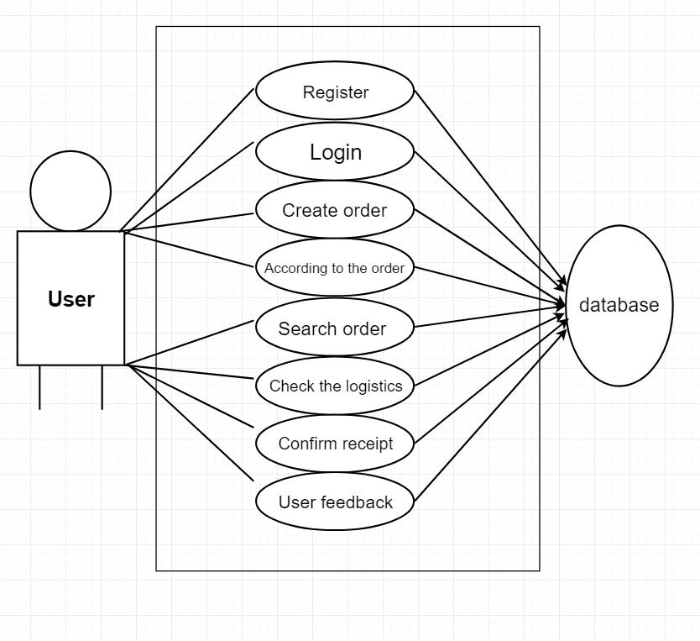

**DFD of Login module**

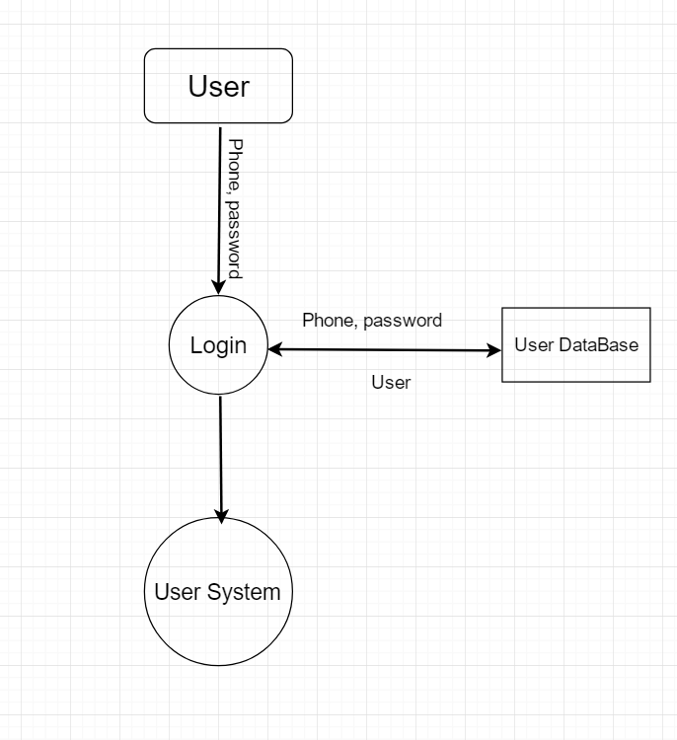

**Requirements module DFD**

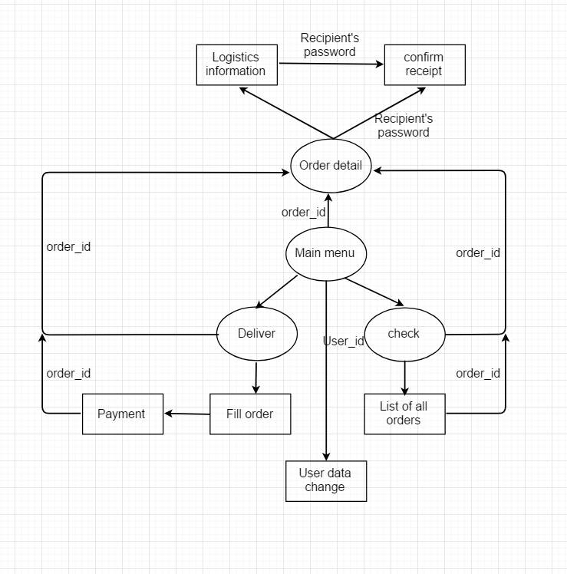

**Data Flow Diagram**

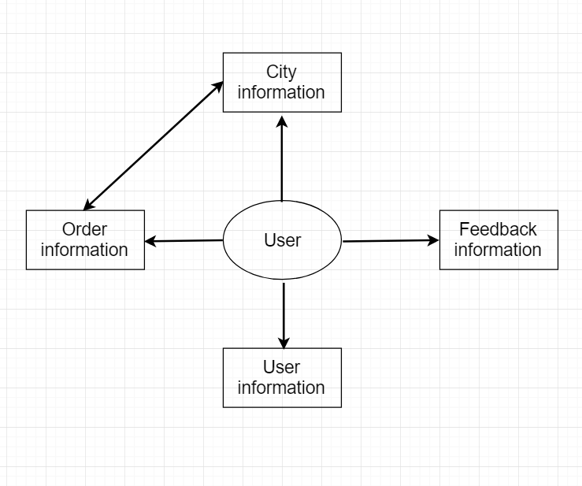

**COST ESTIMATION**

Given Table shows starting and ending date of each work task and total working days. Table also shows concurrency between two or more work tasks. Code generation, Report Working, and Integration & Testing work tasks have been completed in concurrent manner.

|  |  |  |  |  |  |
| --- | --- | --- | --- | --- | --- |
| **Work Done By** | | **Work Task** | **Date** | | **Duration(day)** |
| **Starting** | **Ending** |
| Lion  Edwin Duan | 李雨滋  段熙宇 | PPT Design | 15May09 | 23May09 | 9 |
| Simon  Edwin Duan | 汤显彪  段熙宇 | Code Generation | 6May09 | 23May09 | 18 |
| Lion  Simon  Edwin Duan  Kevin | 李雨滋  汤显彪  段熙宇  朱思宇 | Analysis +  Report Writing +  Testing | 6May09 | 23May09 | 18 |
|  |  |  |  |  | Total Day = 18 |

This software has been developed in 18 days. We work on this project 2.5 hours a day.

The total hours = 18*2.5*4 = 180

Estimated the working cost of manpower is 15yuan/Hour.

Then the total cost of the project is = 180*15 = 2700

So the Estimated Total cost of the Project is Two Thousand , Seven Hundred.

**Login Module**

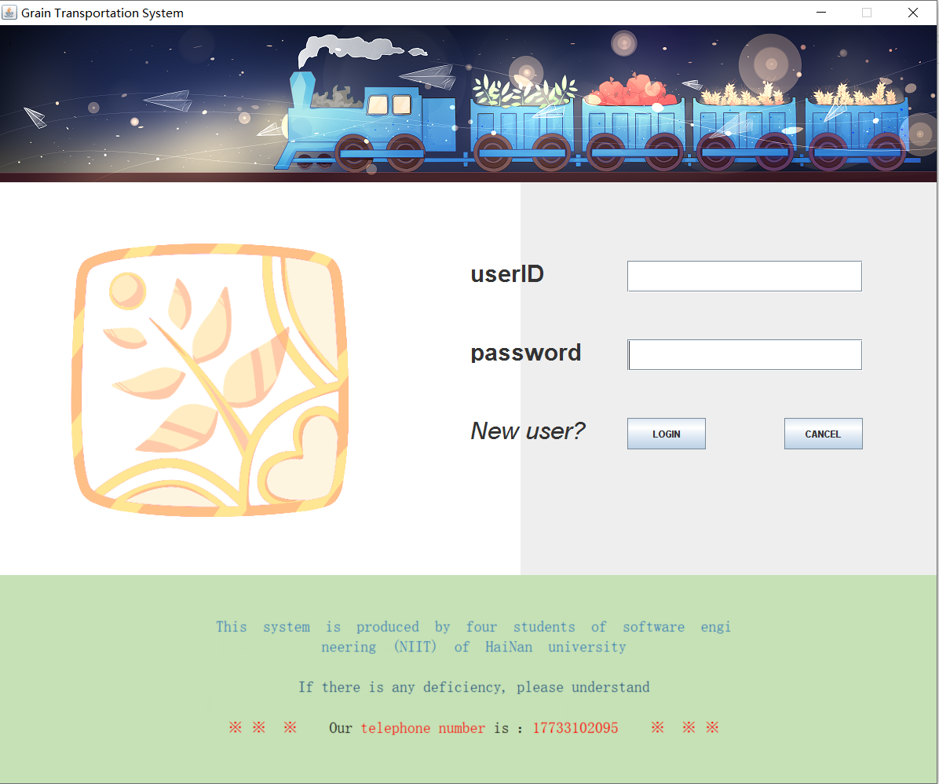

**New User Registration Module**

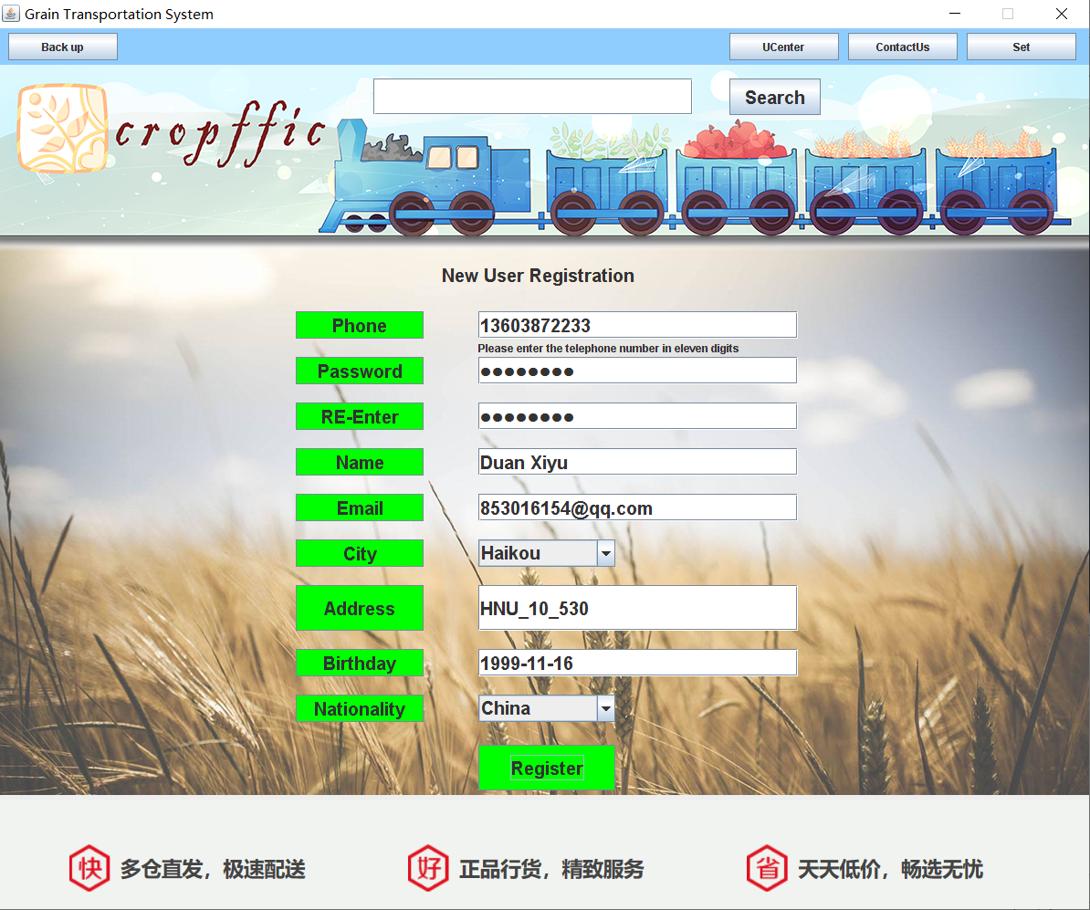

**Function can’t be used before User login in**

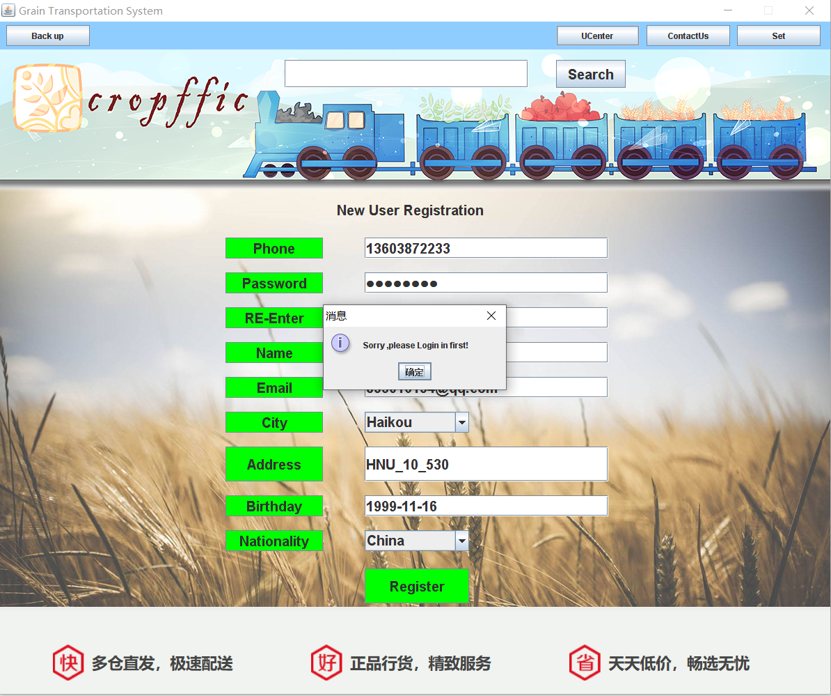

**Primary Key Telephone can’t be same**

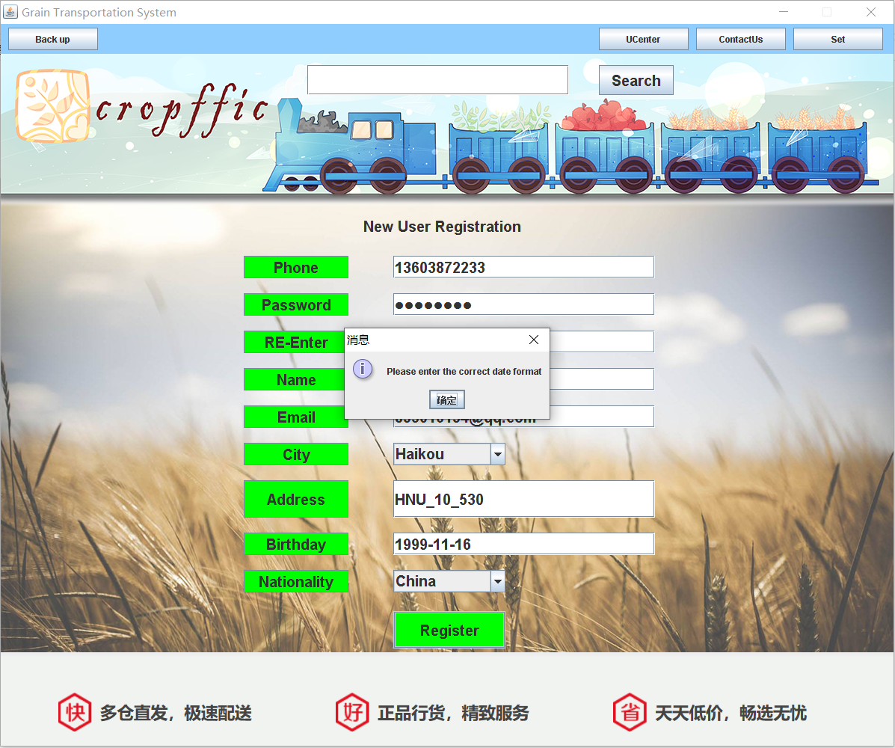

**After everything is well, you will register successfully**

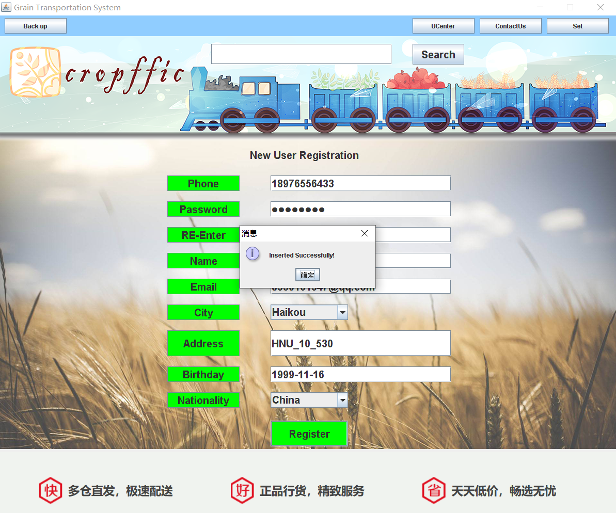

**User name and password prompt Module**

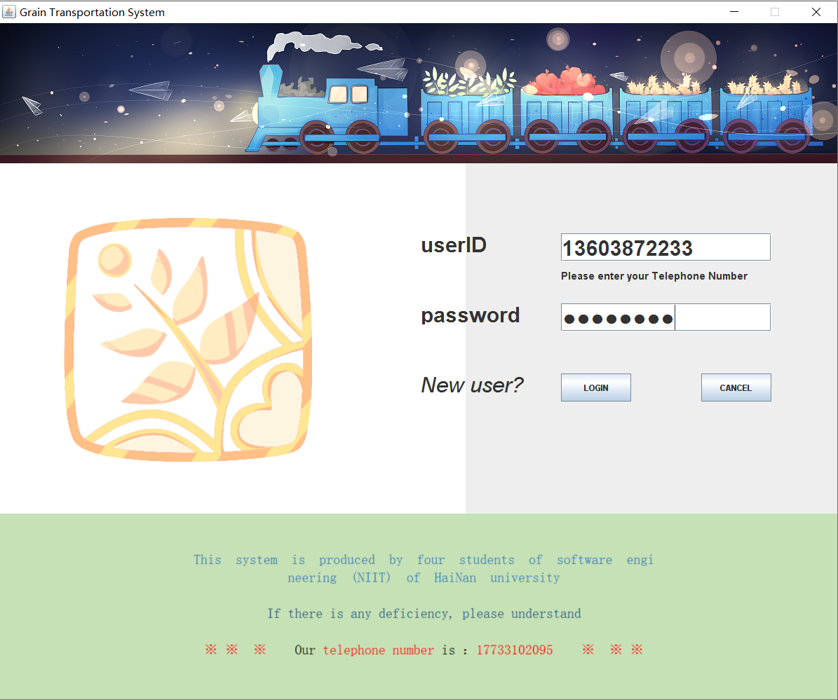

**DBUtil.java**

package niitprojcet;

import java.sql.Connection;

import java.sql.DriverManager;

import java.sql.SQLException;

import java.util.logging.Level;

import java.util.logging.Logger;

public class DBUtil {

private static final String driver = "com.mysql.jdbc.Driver";

private static final String username = "root";

private static final String password = "1234";//注意修改MySql密码。

private static final String url = "jdbc:mysql://localhost:3306/BFTZ";

static {

try {

Class.forName(driver);

} catch (ClassNotFoundException ex) {

Logger.getLogger(DBUtil.class.getName()).log(Level.SEVERE, null, ex);

}

}

public static Connection getConnection() throws SQLException {

return DriverManager.getConnection(url, username, password);

}

}

**Login.java**

package niitprojcet;

import java.awt.Color;

import java.awt.Font;

import java.awt.event.MouseEvent;

import java.awt.event.MouseListener;

import java.awt.event.WindowAdapter;

import java.awt.event.WindowEvent;

import java.sql.Connection;

import java.sql.PreparedStatement;

import java.sql.ResultSet;

import java.sql.SQLException;

import java.util.Date;

import javax.swing.*;

public class Login extends JFrame implements MouseListener {

public void GUI() {

Font font = new Font("a", Font.BOLD, 30);

Font font1 = new Font("a", Font.BOLD, 15);

jltPass = new JLabel("Please enter your Password");

jltPass.setVisible(false);

jltPass.setFont(font1);

jltPass.setBounds(800, 245, 300, 30);

jltID = new JLabel("Please enter your Telephone Number");

jltID.setVisible(false);

jltID.setFont(font1);

jltID.setBounds(800, 145, 300, 30);

jtfID = new JTextField();

jtfID.setBounds(800, 100, 300, 40);

jtfID.setFont(font);

jtfID.addMouseListener(this);

jpfPassword = new JPasswordField();

jpfPassword.setBounds(800, 200, 300, 40);

jpfPassword.setFont(font);

jpfPassword.addMouseListener(this);

jbLogin = new JButton("LOGIN");

jbLogin.setBounds(800, 300, 100, 40);

jbLogin.addMouseListener(this);

jbCancel = new JButton("CANCEL");

jbCancel.setBounds(1000, 300, 100, 40);

jbCancel.addMouseListener(this);

jlID = new JLabel();

jlID.setText("userID");

jlID.setFont(font);

jlID.setBounds(600, 100, 200, 30);

jlPassword = new JLabel();

jlPassword.setText("password");

jlPassword.setFont(font);

jlPassword.setBounds(600, 200, 200, 30);

jlTrip = new JLabel();

jlTrip.setBounds(800, 250, 300, 20);

jlTrip.setFont(new Font("b", Font.BOLD, 20));

jlTrip.setForeground(Color.red);

jlNewUser = new JLabel();

jlNewUser.setText("New user?");

jlNewUser.setFont(new Font("b", Font.ITALIC, 30));

jlNewUser.setBounds(600, 300, 150, 30);

jlNewUser.addMouseListener(this);

jlBack = new JLabel();

jlBack.setIcon(new ImageIcon(getClass().getResource("/pic/Logo_1.png")));

jlBack.setBounds(0, 0, 1200, 500);

jlUp = new JLabel();

jlUp.setIcon(new ImageIcon(getClass().getResource("/pic/Up.png")));

jlUp.setBounds(0, 0, 1200, 200);

jlDown = new JLabel(new ImageIcon(getClass().getResource("/pic/Down1.png")));

jlDown.setBounds(265, 50, 675, 160);

jpMain = new JLayeredPane();

jpMain.setBounds(0, 200, 1200, 500);

jpMain.setLayout(null);

jpMain.add(jlID);

jpMain.add(jlPassword);

jpMain.add(jltID);

jpMain.add(jltPass);

jpMain.add(jlNewUser);

jpMain.add(jbLogin);

jpMain.add(jbCancel);

jpMain.add(jtfID);

jpMain.add(jpfPassword);

jpMain.add(jlTrip);

jpMain.add(jlBack, -1);

jpUp = new JPanel();

jpUp.setBounds(0, 0, 1200, 200);

jpUp.setBackground(Color.BLUE);

jpUp.setLayout(null);

jpUp.add(jlUp);

jpDown = new JPanel();

jpDown.setLayout(null);

jpDown.setBounds(0, 700, 1200, 300);

jpDown.setBackground(new Color(197, 225, 181));

jpDown.add(jlDown);

jf = new JFrame("Grain Transportation System");

jf.setDefaultCloseOperation(WindowConstants.DO_NOTHING_ON_CLOSE);

jf.addWindowListener(new WindowAdapter() {

@Override

public void windowClosing(WindowEvent e) {

int option = JOptionPane.showConfirmDialog(Login.this, "exit?", "提示", JOptionPane.YES_NO_OPTION);

if (option == JOptionPane.YES_OPTION) {

System.exit(0);

}

}

});

jf.setResizable(false);

jf.setSize(1200, 1000);

jf.setVisible(true);

jf.setLocationRelativeTo(null);

jf.setLayout(null);

jf.add(jpMain);

jf.add(jpMain);

jf.add(jpUp);

jf.add(jpDown);

}

public static void main(String args[]) {

Login login = new Login();

login.GUI();

}

public static String Name,Email,Add,Birth,City,Country;

public static String Phone;

public static int ID,Age;

private JFrame jf;

private JPanel jpUp, jpDown;

private JLayeredPane jpMain;

private JLabel jlID, jlPassword, jlUp, jlDown, jlNewUser, jlTrip, jlBack,

jltID,jltPass;

private JButton jbLogin, jbCancel;

private JTextField jtfID;

private JPasswordField jpfPassword;

@Override

public void mouseClicked(MouseEvent e) {

if (e.getSource() == jbLogin) {

Connection con = null;

PreparedStatement ps = null;

ResultSet rs = null;

String input1 = jtfID.getText();

String input2 = jpfPassword.getText();

try {

con = DBUtil.getConnection();

String sql = "select * from Users where user_phone=? and user_password=?";

ps = con.prepareStatement(sql);

ps.setString(1, input1);

ps.setString(2, input2);

rs = ps.executeQuery();

if (input1.length() == 0) {

jlTrip.setText("empty userID");

} else if (input2.length() == 0) {

jlTrip.setText("empty password");

} else if (rs.next()) {

ID=rs.getInt(1);

Phone = input1;

Name = rs.getString(4);

Email=rs.getString(5);

Age=rs.getInt(6);

City=rs.getString(7);

Add=rs.getString(8);

Birth=rs.getString(9);

Country=rs.getString(10);

jf.setVisible(false);

Main main = new Main();

new Thread(main).start();

main.GUI();

} else {

jlTrip.setText("error userID or password");

}

} catch (Exception ex) {

JOptionPane.showMessageDialog(jf, "Please enter the correct information");

} finally {

try {

rs.close();

ps.close();

con.close();

} catch (SQLException ex) {

JOptionPane.showMessageDialog(jf, ex);

}

}

}

if (e.getSource() == jbCancel) {

System.exit(0);

}

if (e.getSource() == jlNewUser) {

new New_User_Code().GUI();

jf.dispose();

}

}

@Override

public void mousePressed(MouseEvent e) {

}

@Override

public void mouseReleased(MouseEvent e) {

}

@Override

public void mouseEntered(MouseEvent e) {

if (e.getSource() == jlNewUser) {

jlNewUser.setForeground(Color.BLUE);

}

if (e.getSource() == jtfID) {

jltID.setVisible(true);

}

if (e.getSource() == jpfPassword) {

jltPass.setVisible(true);

}

}

@Override

public void mouseExited(MouseEvent e) {

if (e.getSource() == jlNewUser) {

jlNewUser.setForeground(Color.BLACK);

}

if (e.getSource() == jtfID) {

jltID.setVisible(false);

}

if (e.getSource() == jpfPassword) {

jltPass.setVisible(false);

}

}

}

**New_User_code.java**

package niitprojcet;

import java.awt.Color;

import java.awt.Font;

import java.awt.event.ActionEvent;

import java.awt.event.ActionListener;

import java.awt.event.MouseEvent;

import java.awt.event.MouseListener;

import java.awt.event.WindowAdapter;

import java.awt.event.WindowEvent;

import java.sql.Connection;

import java.sql.PreparedStatement;

import javax.swing.*;

public class New_User_Code extends JFrame implements ActionListener, MouseListener {

public void GUI() {

Font font = new Font("a", Font.BOLD, 20);

//jltfSearch, jltfPho, jltfName, jltfEmail, jltfAdd, jltfDate,

// jltfPas, jltfRpass;(375, 70, 350, 30);

jltfDate = new JLabel("Please enter your birthday like YYYY-MM-DD");

// jltfPho.setFont(font);

jltfDate.setVisible(false);

jltfDate.setBounds(375, 470, 550, 20);

jltfAdd = new JLabel("Please enter your address less than 120 words");

// jltfPho.setFont(font);

jltfAdd.setVisible(false);

jltfAdd.setBounds(375, 420, 550, 20);

jltfEmail = new JLabel("Please enter a exist Email account");

// jltfPho.setFont(font);

jltfEmail.setVisible(false);

jltfEmail.setBounds(375, 300, 550, 20);

jltfName = new JLabel("Please enter the name less than 30 words");

// jltfPho.setFont(font);

jltfName.setVisible(false);

jltfName.setBounds(375, 250, 550, 20);

jltfRpass = new JLabel("Please enter your Password once more");

// jltfPho.setFont(font);

jltfRpass.setVisible(false);

jltfRpass.setBounds(375, 200, 550, 20);

jltfPas = new JLabel("Please enter your Password less than 50 words");

// jltfPho.setFont(font);

jltfPas.setVisible(false);

jltfPas.setBounds(375, 150, 550, 20);

jltfPho = new JLabel("Please enter the telephone number in eleven digits");

// jltfPho.setFont(font);

jltfPho.setVisible(false);

jltfPho.setBounds(375, 100, 550, 20);

//后方输入框

jbRegi = new JButton("Register");

jbRegi.setFont(font);

jbRegi.setBounds(375, 545, 150, 50);

jbRegi.setBackground(Color.GREEN);

jbRegi.addActionListener(this);

jbRegi.addMouseListener(this);

jcbCountry = new JComboBox();

jcbCountry.setFont(font);

jcbCountry.setBounds(375, 490, 150, 30);

jcbCountry.addItem("China");

jcbCountry.addItem("Amercian");

jcbCountry.addItem("Canada");

jcbCountry.addItem("England");

jcbCountry.addItem("India");

jtfDate = new JTextField();

jtfDate.setFont(font);

jtfDate.setBounds(375, 440, 350, 30);

jtfDate.addMouseListener(this);

jtfAdd = new JTextField();

jtfAdd.setFont(font);

jtfAdd.setBounds(375, 370, 350, 50);

jtfAdd.addMouseListener(this);

jcbCity = new JComboBox();

jcbCity.setFont(font);

jcbCity.setBounds(375, 320, 150, 30);

jcbCity.addItem("Haikou");

jcbCity.addItem("Beijing");

jcbCity.addItem("Shanghai");

jcbCity.addItem("Guanzhou");

jtfEmail = new JTextField();

jtfEmail.setFont(font);

jtfEmail.setBounds(375, 270, 350, 30);

jtfEmail.addMouseListener(this);

jtfName = new JTextField();

jtfName.setFont(font);

jtfName.setBounds(375, 220, 350, 30);

jtfName.addMouseListener(this);

jtfRpass = new JPasswordField();

jtfRpass.setFont(font);

jtfRpass.setBounds(375, 170, 350, 30);

jtfRpass.addMouseListener(this);

jtfPas = new JPasswordField();

jtfPas.setFont(font);

jtfPas.setBounds(375, 120, 350, 30);

jtfPas.addMouseListener(this);

jtfPho = new JTextField();

jtfPho.setFont(font);

jtfPho.setBounds(375, 70, 350, 30);

jtfPho.addMouseListener(this);

//前端名字

jbUser_Country = new JButton("Nationality");

jbUser_Country.setFont(font);

jbUser_Country.setBounds(175, 490, 140, 30);

jbUser_Country.setBackground(Color.GREEN);

jbUser_Date = new JButton("Birthday");

jbUser_Date.setFont(font);

jbUser_Date.setBounds(175, 440, 140, 30);

jbUser_Date.setBackground(Color.GREEN);

jbUser_Address = new JButton("Address");

jbUser_Address.setFont(font);

jbUser_Address.setBounds(175, 370, 140, 50);

jbUser_Address.setBackground(Color.GREEN);

jbUser_City = new JButton("City");

jbUser_City.setFont(font);

jbUser_City.setBounds(175, 320, 140, 30);

jbUser_City.setBackground(Color.GREEN);

jbUser_Email = new JButton("Email");

jbUser_Email.setFont(font);

jbUser_Email.setBounds(175, 270, 140, 30);

jbUser_Email.setBackground(Color.GREEN);

jbUser_Name = new JButton("Name");

jbUser_Name.setFont(font);

jbUser_Name.setBounds(175, 220, 140, 30);

jbUser_Name.setBackground(Color.GREEN);

jbUser_Rpass = new JButton("RE-Enter");

jbUser_Rpass.setFont(font);

jbUser_Rpass.setBounds(175, 170, 140, 30);

jbUser_Rpass.setBackground(Color.GREEN);

jbUser_Pass = new JButton("Password");

jbUser_Pass.setFont(font);

jbUser_Pass.setBounds(175, 120, 140, 30);

jbUser_Pass.setBackground(Color.GREEN);

jbUser_Pho = new JButton("Phone");

jbUser_Pho.setFont(font);

jbUser_Pho.setBounds(175, 70, 140, 30);

jbUser_Pho.setBackground(Color.GREEN);

jlTitle = new JLabel("New User Registration");

jlTitle.setFont(font);

jlTitle.setBounds(335, 5, 300, 50);

// jbUser_ID = new JButton("User ID");

// jbUser_ID.setFont(font);

// jbUser_ID.setBounds(120, 120, 140, 30);

// jbUser_ID.setBackground(Color.GREEN);

//中间部分

jpInfor = new JLayeredPane();

jpInfor.setLayout(null);

jpInfor.setBounds(150, 200, 900, 600);

// jpInfor.setBackground(new Color(144, 205, 255));

jpInfor.add(jlTitle);

// jpInfor.add(jbUser_ID);

jpInfor.add(jbUser_Pho);

jpInfor.add(jbUser_Pass);

jpInfor.add(jbUser_Name);

jpInfor.add(jbUser_Email);

jpInfor.add(jbUser_Rpass);

jpInfor.add(jbUser_City);

jpInfor.add(jbUser_Address);

jpInfor.add(jbUser_Date);

jpInfor.add(jbUser_Country);

jpInfor.add(jtfPho);

jpInfor.add(jtfPas);

jpInfor.add(jtfName);

jpInfor.add(jtfEmail);

jpInfor.add(jtfRpass);

jpInfor.add(jcbCity);

jpInfor.add(jtfAdd);

jpInfor.add(jtfDate);

jpInfor.add(jcbCountry);

jpInfor.add(jbRegi);

jpInfor.add(jltfPho);

jpInfor.add(jltfName);

jpInfor.add(jltfEmail);

jpInfor.add(jltfAdd);

jpInfor.add(jltfDate);

jpInfor.add(jltfPas);

jpInfor.add(jltfRpass);

//上方按钮部分

jtfSearch = new JTextField();

jtfSearch.setFont(font);

jtfSearch.setBounds(410, 15, 350, 40);

jbSearch = new JButton("Search");

jbSearch.setFont(font);

jbSearch.setBounds(800, 15, 100, 40);

jbSearch.addActionListener(this);

jlGround = new JLabel();

jlGround.setBounds(0, 0, 1200, 800);

jlGround.setIcon(new ImageIcon(getClass().getResource("/Pic/Background.png")));

jlpBig = new JLayeredPane();

jlpBig.setLayout(null);

jlpBig.setBackground(Color.YELLOW);

jlpBig.setBounds(0, 40, 1200, 800);

jlpBig.add(jtfSearch);

jlpBig.add(jbSearch);

jlpBig.add(jpInfor);

jlpBig.add(jlGround, -1);

//上面一部分

jbBack = new JButton("Back");

jbBack.setBounds(10, 5, 120, 30);

jbBack.addActionListener(this);

jlName = new JLabel();

jlName.setBounds(100, 0, 250, 40);

jbUCenter = new JButton("UCenter");

jbUCenter.setBounds(800, 5, 120, 30);

jbUCenter.addActionListener(this);

jbContactUs = new JButton("ContactUs");

jbContactUs.setBounds(930, 5, 120, 30);

jbContactUs.addActionListener(this);

jbSet = new JButton("Set");

jbSet.setBounds(1060, 5, 120, 30);

jbSet.addActionListener(this);

jpUp = new JPanel();

jpUp.setLayout(null);

jpUp.setBounds(0, 0, 1200, 40);

jpUp.setBackground(new Color(144, 205, 255));

jpUp.add(jbUCenter);

jpUp.add(jbSet);

jpUp.add(jbContactUs);

jpUp.add(jlName);

jpUp.add(jbBack);

//下面一部分

jlDown = new JLabel();

jlDown.setIcon(new ImageIcon(getClass().getResource("/Pic/Down.png")));

jlDown.setBounds(0, 0, 1200, 160);

jpDown = new JPanel();

jpDown.setBounds(0, 840, 1200, 160);

// jpDown.setBackground(Color.GREEN);

jpDown.add(jlDown);

jf = new JFrame("Grain Transportation System");

jf.setDefaultCloseOperation(WindowConstants.DO_NOTHING_ON_CLOSE);

jf.addWindowListener(new WindowAdapter() {

@Override

public void windowClosing(WindowEvent e) {

int option = JOptionPane.showConfirmDialog(New_User_Code.this, "exit?", "提示", JOptionPane.YES_NO_OPTION);

if (option == JOptionPane.YES_OPTION) {

System.exit(0);

}

}//关闭窗口

});

jf.setResizable(false);

jf.setSize(1200, 1000);

jf.setVisible(true);

jf.setLocationRelativeTo(null);

jf.setLayout(null);

jf.add(jpUp);

jf.add(jlpBig);

jf.add(jpDown);

// jf.add(jpInfor);

}

public static void main(String[] args) {

new New_User_Code().GUI();//运行GUI

}

private JFrame jf;

private JPanel jpUp, jpDown;

private JLayeredPane jlpBig, jpInfor;

private JButton jbUCenter, jbContactUs, jbSet, jbSearch, jbBack,

jbUser_ID, jbUser_Pho, jbUser_Pass, jbUser_Name, jbUser_Email,

jbUser_Rpass, jbUser_City, jbUser_Address, jbUser_Date, jbUser_Country,

jbRegi;

private JLabel jlGround, jlName, jlDown, jlTitle,

jltfSearch, jltfPho, jltfName, jltfEmail, jltfAdd, jltfDate,

jltfPas, jltfRpass;

;

private JTextField jtfSearch, jtfPho, jtfName, jtfEmail, jtfAdd, jtfDate;

private JPasswordField jtfPas, jtfRpass;

private JComboBox jcbCity, jcbCountry;

@Override

public void actionPerformed(ActionEvent e) {

if (e.getSource() == jbUCenter) {

JOptionPane.showMessageDialog(this, "Sorry ,please Login in first!");

}

if (e.getSource() == jbContactUs) {

JOptionPane.showMessageDialog(this, "Sorry ,please Login in first!");

}

if (e.getSource() == jbSet) {

JOptionPane.showMessageDialog(this, "Sorry ,please Login in first!");

}

if (e.getSource() == jbSearch) {

JOptionPane.showMessageDialog(this, "Sorry ,please Login in first!");

}

if (e.getSource() == jbBack) {

jf.dispose();

new Login().GUI();

}

if (e.getSource() == jbRegi) {

if (jtfPas.getText().equals(jtfRpass.getText())) {

try {

Connection cn = DBUtil.getConnection();//连接数据库

String sql = "INSERT INTO Users"

+ "(User_ID,User_Phone,User_Password,User_Name,User_Email,User_City,User_Address,User_DateOfBirth,User_Country) "

+ "VALUES (null,?,?,?,?,?,?,?,?)";

PreparedStatement pdt = cn.prepareStatement(sql);

//获取接口，进行SQL语句的执行

pdt.setString(1, jtfPho.getText());

pdt.setString(2, jtfPas.getText());

// pdt.setString(3, jtfRpass.getText());

pdt.setString(3, jtfName.getText());

pdt.setString(4, jtfEmail.getText());

pdt.setString(5, jcbCity.getSelectedItem().toString());

pdt.setString(6, jtfAdd.getText());

pdt.setString(7, jtfDate.getText());

pdt.setString(8, jcbCountry.getSelectedItem().toString());

int count = pdt.executeUpdate();//将数据库更新的数据数量存在count中，

if (count > 0) {

JOptionPane.showMessageDialog(this, "Inserted Successfully!");

jf.dispose();

new Login().GUI();

// jf.dispose();

// Login l = new Login();

// l.show();

} else {

JOptionPane.showMessageDialog(this, "Failed to Insert...");

}

} catch (Exception ex) {

JOptionPane.showMessageDialog(this, "Please enter the correct date format");

}

} else {

JOptionPane.showMessageDialog(this, "Passwoed is not same!");

}

}

}

@Override

public void mouseEntered(MouseEvent ESearch) {

if (ESearch.getSource() == jtfPho) {

jltfPho.setVisible(true);

}

if (ESearch.getSource() == jtfName) {

jltfName.setVisible(true);

}

if (ESearch.getSource() == jtfEmail) {

jltfEmail.setVisible(true);

}

if (ESearch.getSource() == jtfAdd) {

jltfAdd.setVisible(true);

}

if (ESearch.getSource() == jtfDate) {

jltfDate.setVisible(true);

}

if (ESearch.getSource() == jtfPas) {

jltfPas.setVisible(true);

}

if (ESearch.getSource() == jtfRpass) {

jltfRpass.setVisible(true);

}

}

@Override

public void mouseExited(MouseEvent ESearch) {

if (ESearch.getSource() == jtfPho) {

jltfPho.setVisible(false);

}

if (ESearch.getSource() == jtfName) {

jltfName.setVisible(false);

}

if (ESearch.getSource() == jtfEmail) {

jltfEmail.setVisible(false);

}

if (ESearch.getSource() == jtfAdd) {

jltfAdd.setVisible(false);

}

if (ESearch.getSource() == jtfDate) {

jltfDate.setVisible(false);

}

if (ESearch.getSource() == jtfPas) {

jltfPas.setVisible(false);

}

if (ESearch.getSource() == jtfRpass) {

jltfRpass.setVisible(false);

}

}

@Override

public void mouseClicked(MouseEvent e) {

}

@Override

public void mousePressed(MouseEvent e) {

}

@Override

public void mouseReleased(MouseEvent e) {

}

}

**User Interface Module**

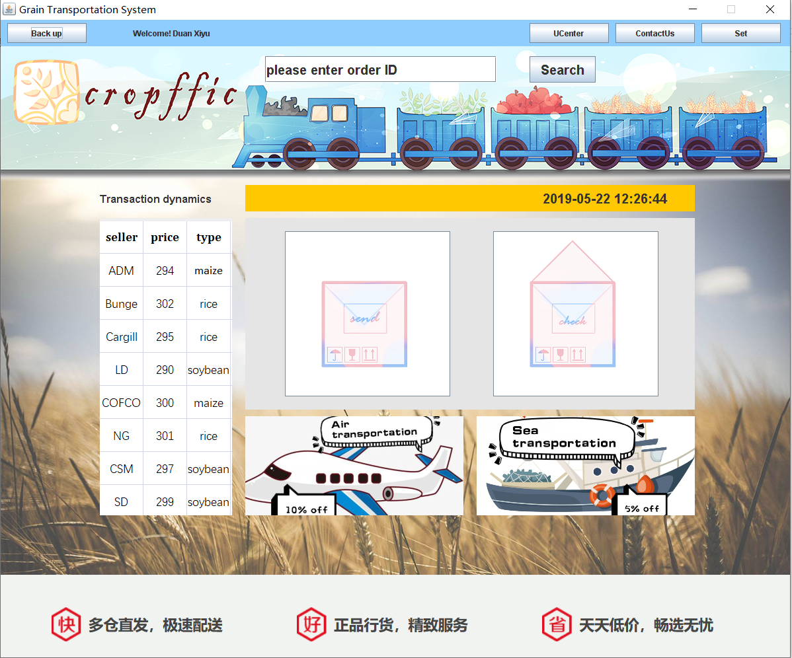

**Main.java**

package niitprojcet;

import java.awt.Color;

import java.awt.Font;

import java.awt.event.ActionEvent;

import java.awt.event.ActionListener;

import java.awt.event.WindowAdapter;

import java.awt.event.WindowEvent;

import java.sql.*;

import java.text.SimpleDateFormat;

import java.util.Date;

import java.util.logging.Level;

import java.util.logging.Logger;

import javax.swing.*;

public class Main extends JFrame implements Runnable, ActionListener {

public void GUI() {

//中间一大块

Font font = new Font("a", Font.BOLD, 20);

jtfSearch = new JTextField();

jtfSearch.setFont(font);

jtfSearch.setBounds(400, 15, 350, 40);

jtfSearch.setText("please enter order ID");

jbSearch = new JButton("Search");

jbSearch.setFont(font);

jbSearch.setBounds(800, 15, 100, 40);

jbSearch.addActionListener(this);

jpLeft = new JLabel("Transaction dynamics");

jpLeft.setFont(new Font("a", Font.BOLD, 16));

jpLeft.setBounds(150, 210, 200, 40);

jpLeft.setBackground(Color.ORANGE);

jlTime = new JLabel();

jlTime.setBounds(450, 0, 240, 40);

jlTime.setBackground(Color.ORANGE);

jlTime.setText(new SimpleDateFormat("yyyy-MM-dd HH:mm:ss").format(new Date()));

jlTime.setFont(font);

jpRight = new JPanel();

jpRight.setLayout(null);

jpRight.setBounds(370, 210, 680, 40);

jpRight.setBackground(Color.ORANGE);

jpRight.add(jlTime);

jlPic =new JLabel(new ImageIcon(getClass().getResource("/pic/Ad.png")));

jpPic = new JPanel();

jpPic.setBounds(150, 260, 200, 450);

jpPic.add(jlPic);

jbPut = new JButton(new ImageIcon(getClass().getResource("/pic/send.png")));

jbPut.setBounds(60, 20, 250, 250);

jbPut.addActionListener(this);

jbGet = new JButton(new ImageIcon(getClass().getResource("/pic/check.png")));

jbGet.setBounds(375, 20, 250, 250);

jbGet.addActionListener(this);

jpMain = new JPanel();

jpMain.setLayout(null);

jpMain.setBounds(370, 260, 680, 290);

jpMain.setBackground(new Color(229,229,229));

jpMain.add(jbPut);

jpMain.add(jbGet);

jlLeftAd = new JLabel();

jlLeftAd.setBounds(0, 0, 330, 150);

jlLeftAd.setIcon(new ImageIcon(getClass().getResource("/pic/Airplane.png")));

jpLeftAd = new JLayeredPane();

jpLeftAd.setLayout(null);

jpLeftAd.setBounds(370, 560, 330, 150);

jpLeftAd.add(jlLeftAd);

jlRightAd = new JLabel();

jlRightAd.setBounds(0, 0, 330, 150);

jlRightAd.setIcon(new ImageIcon(getClass().getResource("/pic/Train.png")));

jpRightAd = new JLayeredPane();

jpRightAd.setLayout(null);

jpRightAd.setBounds(720, 560, 330, 150);

jpRightAd.add(jlRightAd);

jlGround = new JLabel();

jlGround.setBounds(0, 0, 1200, 800);

jlGround.setIcon(new ImageIcon(getClass().getResource("/pic/Background.png")));

jlpBig = new JLayeredPane();

jlpBig.setLayout(null);

jlpBig.setBounds(0, 40, 1200, 800);

jlpBig.add(jpMain);

jlpBig.add(jpLeft);

jlpBig.add(jpRight);

jlpBig.add(jpLeftAd);

jlpBig.add(jpRightAd);

jlpBig.add(jtfSearch);

jlpBig.add(jbSearch);

jlpBig.add(jpPic);

jlpBig.add(jlGround, -1);

//下面一部分

jlDown = new JLabel();

jlDown.setIcon(new ImageIcon(getClass().getResource("/pic/Down.png")));

jlDown.setBounds(0, 0, 1200, 160);

jpDown = new JPanel();

jpDown.setLayout(null);

jpDown.setBounds(0, 840, 1200, 160);

jpDown.setBackground(Color.GREEN);

jpDown.add(jlDown);

//上面一部分

jbBack = new JButton("Back");

jbBack.setBounds(10, 5, 120, 30);

jbBack.addActionListener(this);

jlUserName = new JLabel("Welcome! " + Login.Name);

jlUserName.setBounds(200, 0, 250, 40);

jbUCenter = new JButton("UCenter");

jbUCenter.setBounds(800, 5, 120, 30);

jbUCenter.addActionListener(this);

jbContactUs = new JButton("ContactUs");

jbContactUs.setBounds(930, 5, 120, 30);

jbContactUs.addActionListener(this);

jbSet = new JButton("Set");

jbSet.setBounds(1060, 5, 120, 30);

jbSet.addActionListener(this);

jpUp = new JPanel();

jpUp.setLayout(null);

jpUp.setBounds(0, 0, 1200, 40);

jpUp.setBackground(new Color(144, 205, 255));

jpUp.add(jbBack);

jpUp.add(jbUCenter);

jpUp.add(jbSet);

jpUp.add(jbContactUs);

jpUp.add(jlUserName);

jf = new JFrame("Grain Transportation System");

jf.setDefaultCloseOperation(WindowConstants.DO_NOTHING_ON_CLOSE);

jf.addWindowListener(new WindowAdapter() {

@Override

public void windowClosing(WindowEvent e) {

int option = JOptionPane.showConfirmDialog(Main.this, "exit?", "提示", JOptionPane.YES_NO_OPTION);

if (option == JOptionPane.YES_OPTION) {

System.exit(0);

}

}

});

jf.setResizable(false);

jf.setSize(1200, 1000);

jf.setVisible(true);

jf.setLocationRelativeTo(null);

jf.setLayout(null);

jf.add(jpUp);

jf.add(jlpBig);

jf.add(jpDown);

}

public static void main(String[] args) {

Main main = new Main();

new Thread(main).start();

main.GUI();

}

public static int Flag = 0, Price,X1,X2,Y1,Y2;

public static String Arr, Type;

public static String orderID;

public static String Info;

public static String ID1;

public static String ID2;

public static String Name1, HName;

public static String Name2;

public static String City1;

public static String City2;

private JFrame jf;

private JPanel jpUp, jpMain, jpRight, jpPic, jpDown;

private JLayeredPane jlpBig, jpLeftAd,jpRightAd;

private JButton jbUCenter, jbContactUs, jbSet, jbPut, jbGet, jbSearch, jbBack;

private JLabel jlTime, jlGround, jlUserName, jlLeftAd,jlRightAd, jlDown,jlPic, jpLeft;

private JTextField jtfSearch;

@Override

public void run() {

while (true) {

try {

Thread.sleep(1000);

jlTime.setText(new SimpleDateFormat("yyyy-MM-dd HH:mm:ss").format(new Date()));

} catch (InterruptedException ex) {

Logger.getLogger(Main.class.getName()).log(Level.SEVERE, null, ex);

}

}

}

@Override

public void actionPerformed(ActionEvent e) {

if (e.getSource() == jbUCenter) {

// JOptionPane.showMessageDialog(jf, "This function is not currently on……");

Self_centery s = new Self_centery();

jf.dispose();

s.GUI();

}

if (e.getSource() == jbSet) {

JOptionPane.showMessageDialog(jf, "This function is not currently on……");

}

if (e.getSource() == jbPut) {

jf.dispose();

new Deliver().GUI();

}

if(e.getSource()==jbGet){

jf.dispose();

new Get().GUI();

}

if (e.getSource() == jbBack) {

jf.dispose();

new Login().GUI();

}

if (e.getSource() == jbContactUs) {

new ContactUs();

}

if (e.getSource() == jbSearch) {

if (jtfSearch.getText().length() > 0) {

orderID = jtfSearch.getText();

Connection con = null;

PreparedStatement ps = null;

ResultSet rs = null;

try {

con = DBUtil.getConnection();

String sql = "select * from Order_forms where Order_id=?";

ps = con.prepareStatement(sql);

ps.setString(1, jtfSearch.getText());

rs = ps.executeQuery();

if (rs.next()) {

HName = rs.getString(8);

Info = rs.getString(9);

ID1 = rs.getString(2);

Name1 = rs.getString(3);

City1 = rs.getString(4);

ID2 = rs.getString(5);

Name2 = rs.getString(6);

City2 = rs.getString(7);

Arr = rs.getString(13);

Price = rs.getInt(11);

Type = rs.getString(10);

Flag = 1;

} else {

Flag = 0;

}

sql = "select * from Citys where city_Neme=?";

ps = con.prepareStatement(sql);

ps.setString(1, City1);

rs = ps.executeQuery();

while (rs.next()) {

X1 = rs.getInt(4);

Y1 = rs.getInt(5);

}

sql = "select * from Citys where City_neme=?";

ps = con.prepareStatement(sql);

ps.setString(1,City2 );

rs = ps.executeQuery();

while (rs.next()) {

X2 = rs.getInt(4);

Y2 = rs.getInt(5);

}

jf.dispose();

new Search().GUI();

} catch (SQLException ex) {

JOptionPane.showMessageDialog(jf, ex);

} finally {

try {

rs.close();

ps.close();

con.close();

} catch (SQLException ex) {

JOptionPane.showMessageDialog(jf, ex);

}

}

}

}

}

}

**User Personal Center Module**

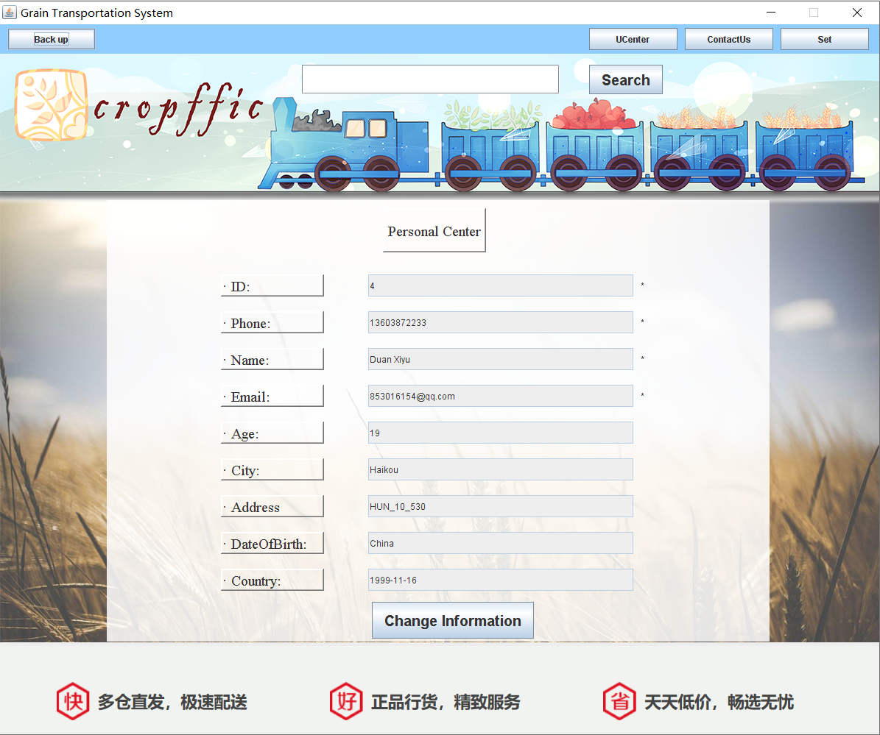

**Update User profile data**

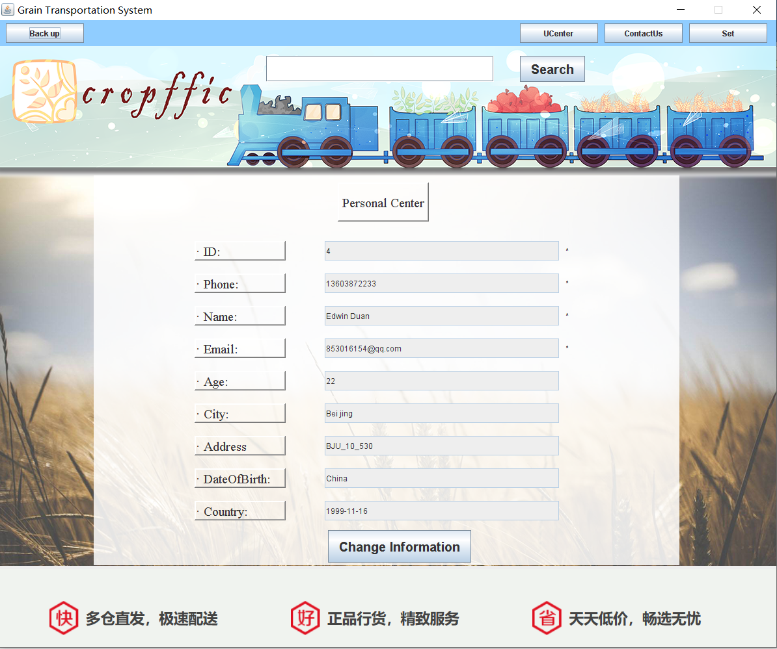

**Self_Centery.java**

package niitprojcet;

import java.awt.Color;

import java.awt.Font;

import java.awt.event.ActionEvent;

import java.awt.event.ActionListener;

import java.awt.event.WindowAdapter;

import java.awt.event.WindowEvent;

import java.sql.Connection;

import java.sql.PreparedStatement;

import java.sql.ResultSet;

import java.sql.SQLException;

import java.util.logging.Level;

import java.util.logging.Logger;

import javax.swing.*;

import javax.swing.border.BevelBorder;

public class Self_centery extends JFrame implements ActionListener {

public void GUI() {

Font font = new Font("a", Font.BOLD, 20);

jti = new JLabel(" ");

jti.setBounds(90, 210, 150, 150);

// jt1.setBackground(Color.green);

//星星

jlID2 = new JLabel("*");

jlID2.setBounds(720, 100, 30, 30);

jlPho2 = new JLabel("*");

jlPho2.setBounds(720, 150, 30, 30);

jlName2 = new JLabel("*");

jlName2.setBounds(720, 200, 30, 30);

jlEmail2 = new JLabel("*");

jlEmail2.setBounds(720, 250, 30, 30);

//文本框

jtID = new JTextField();

jtID.setBounds(350, 100, 360, 30);

jtID.setEditable(false);

jtPho = new JTextField();

jtPho.setBounds(350, 150, 360, 30);

jtPho.setEditable(false);

jtName = new JTextField();

jtName.setBounds(350, 200, 360, 30);

jtEmail = new JTextField();

jtEmail.setBounds(350, 250, 360, 30);

jtAge = new JTextField();

jtAge.setBounds(350, 300, 360, 30);

jtCity = new JTextField();

jtCity.setBounds(350, 350, 360, 30);

jtAdd = new JTextField();

jtAdd.setBounds(350, 400, 360, 30);

jtCountry = new JTextField();

jtCountry.setBounds(350, 450, 360, 30);

jtBirth = new JTextField();

jtBirth.setBounds(350, 500, 360, 30);

jtID.setText("" + Login.ID);

jtPho.setText("" + Login.Phone);

jtName.setText("" + Login.Name);

jtEmail.setText("" + Login.Email);

jtAge.setText("" + Login.Age);

jtCity.setText("" + Login.City);

jtAdd.setText("" + Login.Add);

jtCountry.setText("" + Login.Country);

jtBirth.setText("" + Login.Birth);

jtName.setEditable(false);

jtEmail.setEditable(false);

jtAge.setEditable(false);

jtCity.setEditable(false);

jtAdd.setEditable(false);

jtCountry.setEditable(false);

jtBirth.setEditable(false);

jtitle = new JLabel(" Personal Center");

jtitle.setBounds(370, 10, 140, 60);

jtitle.setFont(new Font("serif", Font.PLAIN, 20));

jtitle.setBorder(BorderFactory.createBevelBorder(BevelBorder.RAISED));

jlID = new JLabel("· ID:");

jlID.setFont(new Font("serif", Font.PLAIN, 20));

jlID.setBounds(150, 100, 140, 30);

jlID.setBorder(BorderFactory.createBevelBorder(BevelBorder.RAISED));

jlPho = new JLabel("· Phone:");

jlPho.setFont(new Font("serif", Font.PLAIN, 20));

jlPho.setBounds(150, 150, 140, 30);

jlPho.setBorder(BorderFactory.createBevelBorder(BevelBorder.RAISED));

jlName3 = new JLabel("· Name:");

jlName3.setFont(new Font("serif", Font.PLAIN, 20));

jlName3.setBounds(150, 200, 140, 30);

jlName3.setBorder(BorderFactory.createBevelBorder(BevelBorder.RAISED));

jlEmail = new JLabel("· Email:");

jlEmail.setFont(new Font("serif", Font.PLAIN, 20));

jlEmail.setBounds(150, 250, 140, 30);

jlEmail.setBorder(BorderFactory.createBevelBorder(BevelBorder.RAISED));

jlAge = new JLabel("· Age:");

jlAge.setFont(new Font("serif", Font.PLAIN, 20));

jlAge.setBounds(150, 300, 140, 30);

jlAge.setBorder(BorderFactory.createBevelBorder(BevelBorder.RAISED));

jlCity = new JLabel("· City:");

jlCity.setFont(new Font("serif", Font.PLAIN, 20));

jlCity.setBounds(150, 350, 140, 30);

jlCity.setBorder(BorderFactory.createBevelBorder(BevelBorder.RAISED));

jlAdd = new JLabel("· Address");

jlAdd.setFont(new Font("serif", Font.PLAIN, 20));

jlAdd.setBounds(150, 400, 140, 30);

jlAdd.setBorder(BorderFactory.createBevelBorder(BevelBorder.RAISED));

jlCountry = new JLabel("· DateOfBirth:");

jlCountry.setFont(new Font("serif", Font.PLAIN, 20));

jlCountry.setBounds(150, 450, 140, 30);

jlCountry.setBorder(BorderFactory.createBevelBorder(BevelBorder.RAISED));

jlBirth = new JLabel("· Country:");

jlBirth.setFont(new Font("serif", Font.PLAIN, 20));

jlBirth.setBounds(150, 500, 140, 30);

jlBirth.setBorder(BorderFactory.createBevelBorder(BevelBorder.RAISED));

jbChange = new JButton("Change Information");

jbChange.setBounds(355, 545, 220, 50);

jbChange.setFont(font);

jbChange.addActionListener(this);

jbSubmit = new JButton("Submit");

jbSubmit.setBounds(355, 545, 220, 50);

jbSubmit.setFont(font);

jbSubmit.addActionListener(this);

//面板

jpMain = new JLayeredPane();

jpMain.setLayout(null);

jpMain.setBounds(150, 200, 900, 600);

jpMain.add(jtitle);

jpMain.add(jti);

//添加标签

jpMain.add(jlID);

jpMain.add(jlPho);

jpMain.add(jlName3);

jpMain.add(jlEmail);

jpMain.add(jlAge);

jpMain.add(jlCity);

jpMain.add(jlAdd);

jpMain.add(jlCountry);

jpMain.add(jlBirth);

//添加文本框

jpMain.add(jtID);

jpMain.add(jtPho);

jpMain.add(jtName);

jpMain.add(jtEmail);

jpMain.add(jtAge);

jpMain.add(jtCity);

jpMain.add(jtAdd);

jpMain.add(jtCountry);

jpMain.add(jtBirth);

//添加星星

jpMain.add(jlID2);

jpMain.add(jlPho2);

jpMain.add(jlName2);

jpMain.add(jlEmail2);

jpMain.add(jbChange);

//上方按钮部分

jtfSearch = new JTextField();

jtfSearch.setFont(font);

jtfSearch.setBounds(410, 15, 350, 40);

jbSearch = new JButton("Search");

jbSearch.setFont(font);

jbSearch.setBounds(800, 15, 100, 40);

jlGround = new JLabel();

jlGround.setBounds(0, 0, 1200, 800);

jlGround.setIcon(new ImageIcon(getClass().getResource("/Pictures/Background2.png")));

jlpBig = new JLayeredPane();

jlpBig.setLayout(null);

jlpBig.setBackground(Color.YELLOW);

jlpBig.setBounds(0, 40, 1200, 800);

jlpBig.add(jtfSearch);

jlpBig.add(jbSearch);

jlpBig.add(jpMain);

jlpBig.add(jlGround, -1);

//上面一部分

jbBack = new JButton("Back");

jbBack.setBounds(10, 5, 120, 30);

jbBack.addActionListener(this);

jlName = new JLabel();

jlName.setBounds(100, 0, 250, 40);

jbUCenter = new JButton("UCenter");

jbUCenter.setBounds(800, 5, 120, 30);

jbUCenter.addActionListener(this);

jbContactUs = new JButton("ContactUs");

jbContactUs.setBounds(930, 5, 120, 30);

jbContactUs.addActionListener(this);

jbSet = new JButton("Set");

jbSet.setBounds(1060, 5, 120, 30);

jbSet.addActionListener(this);

jpUp = new JPanel();

jpUp.setLayout(null);

jpUp.setBounds(0, 0, 1200, 40);

jpUp.setBackground(new Color(144, 205, 255));

jpUp.add(jbUCenter);

jpUp.add(jbSet);

jpUp.add(jbContactUs);

jpUp.add(jlName);

jpUp.add(jbBack);

//下面一部分

jlDown = new JLabel();

jlDown.setIcon(new ImageIcon(getClass().getResource("/Pictures/Down.png")));

jlDown.setBounds(0, 0, 1200, 160);

jpDown = new JPanel();

jpDown.setBounds(0, 840, 1200, 160);

// jpDown.setBackground(Color.GREEN);

jpDown.add(jlDown);

jf = new JFrame("Grain Transportation System");

jf.setDefaultCloseOperation(WindowConstants.DO_NOTHING_ON_CLOSE);

jf.addWindowListener(new WindowAdapter() {

@Override

public void windowClosing(WindowEvent e) {

int option = JOptionPane.showConfirmDialog(null, "exit?", "提示", JOptionPane.YES_NO_OPTION);

if (option == JOptionPane.YES_OPTION) {

System.exit(0);

}

}//关闭窗口

});

jf.setResizable(false);

jf.setSize(1200, 1000);

jf.setVisible(true);

jf.setLocationRelativeTo(null);

jf.setLayout(null);

jf.add(jpUp);

jf.add(jlpBig);

jf.add(jpDown);

// jf.add(jpMain);

}

public static void main(String[] args) {

new Self_centery().GUI();

}

private JFrame jf;

private JPanel jpUp, jpDown;

private JLayeredPane jlpBig;

private JButton jbUCenter, jbContactUs, jbSet, jbSearch, jbChange, jbSubmit, jbBack;

private JLabel jlGround, jlName, jlDown;

private JTextField jtfSearch;

private JLayeredPane jpMain;

private JLabel jtitle, jlID, jlPho, jlName3, jlEmail, jlAge, jlCity, jlAdd, jlCountry, jlBirth, jti;

private JTextField jtID, jtPho, jtName, jtEmail, jtAge, jtCity, jtAdd, jtCountry, jtBirth;

private JLabel jlID2, jlPho2, jlName2, jlEmail2;

@Override

public void actionPerformed(ActionEvent e) {

if (e.getSource() == jbUCenter) {

JOptionPane.showMessageDialog(this, "Sorry ,please Login in first!");

}

if (e.getSource() == jbContactUs) {

JOptionPane.showMessageDialog(this, "Sorry ,please Login in first!");

}

if (e.getSource() == jbSet) {

JOptionPane.showMessageDialog(this, "Sorry ,please Login in first!");

}

if (e.getSource() == jbSearch) {

JOptionPane.showMessageDialog(this, "Sorry ,please Login in first!");

}

if (e.getSource() == jbBack) {

jf.dispose();

Main main = new Main();

main.GUI();

new Thread(main).start();

}

if (e.getSource() == jbChange) {

jtName.setEditable(true);

jtAge.setEditable(true);

jtCity.setEditable(true);

jtAdd.setEditable(true);

jtCountry.setEditable(true);

jtBirth.setEditable(true);

jpMain.remove(jbChange);

jpMain.add(jbSubmit);

// try {

// Connection cn=DBClass.getConnection();//连接数据库

// String sql="Select * from Users where User_Phone = '"+Login.ID+"'";

// PreparedStatement pdt = cn.prepareStatement(sql);

// Result rs = pdt

}

if (e.getSource() == jbSubmit) {

Connection con = null;

PreparedStatement ps = null;

ResultSet rs = null;

try {

con = (Connection) DBUtil.getConnection();

String sql = "update users set user_name=?,user_age=?,user_city=?,user_address=?,user_country=?,user_dateofbirth=? where user_id=?";

ps = con.prepareStatement(sql);

ps.setString(1, jtName.getText());

ps.setInt(2, Integer.parseInt(jtAge.getText()));

ps.setString(3, jtCity.getText());

ps.setString(4, jtAdd.getText());

ps.setString(5, jtCountry.getText());

ps.setString(6, jtBirth.getText());

ps.setInt(7, Login.ID);

ps.execute();

sql = "select * from Users where user_ID=?";

ps = con.prepareStatement(sql);

ps.setInt(1, Login.ID);

rs = ps.executeQuery();

while (rs.next()) {

Login.Name = rs.getString(4);

Login.Email = rs.getString(5);

Login.Age = rs.getInt(6);

Login.City = rs.getString(7);

Login.Add = rs.getString(8);

Login.Birth = rs.getString(9);

Login.Country = rs.getString(10);

}

} catch (Exception ex) {

JOptionPane.showMessageDialog(this, ex);

} finally {

try {

ps.close();

con.close();//jtID,jtPho,jtName,jtEmail,jtAge,jtCity,jtAdd,jtCountry,jtBirth;

} catch (SQLException ex) {

Logger.getLogger(Self_centery.class.getName()).log(Level.SEVERE, null, ex);

}

}

jtName.setEditable(false);

jtAge.setEditable(false);

jtCity.setEditable(false);

jtAdd.setEditable(false);

jtCountry.setEditable(false);

jtBirth.setEditable(false);

jpMain.remove(jbSubmit);

jpMain.add(jbChange);

}

}

**Leave the message for the company Module**

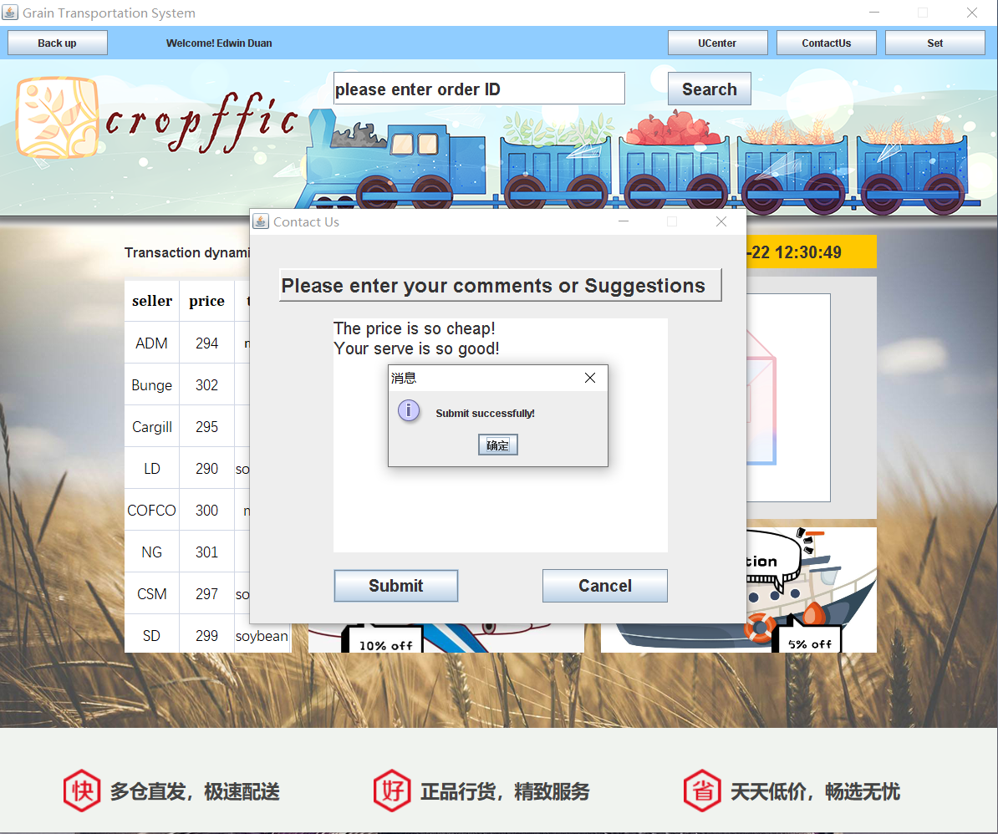

**ContactUs.java**

package niitprojcet;

import java.sql.*;

import java.awt.Color;

import java.awt.Font;

import java.awt.event.ActionEvent;

import java.awt.event.ActionListener;

import java.sql.SQLException;

import javax.swing.*;

import javax.swing.border.BevelBorder;

public class ContactUs implements ActionListener {

public ContactUs() {

Font font = new Font("Arial", Font.BOLD, 20);

jlTrip = new JLabel("Please enter your comments or Suggestions");

jlTrip.setBounds(35, 40, 530, 40);

jlTrip.setFont(new Font("Arial", Font.BOLD, 24));

jlTrip.setBorder(BorderFactory.createBevelBorder(BevelBorder.RAISED));

jtaComment = new JTextArea();

jtaComment.setBounds(100, 100, 400, 280);

jtaComment.setLineWrap(true);

jtaComment.setWrapStyleWord(true);

jtaComment.setFont(new Font("Arial", Font.PLAIN, 20));

jbSubmit = new JButton("Submit");

jbSubmit.setBounds(100, 400, 150, 40);

jbSubmit.setFont(font);

jbSubmit.addActionListener(this);

jbCancel = new JButton("Cancel");

jbCancel.setBounds(350, 400, 150, 40);

jbCancel.setFont(font);

jbCancel.addActionListener(this);

jp = new JPanel();

jp.setLayout(null);

jp.setBounds(0, 0, 600, 500);

jp.add(jbSubmit);

jp.add(jbCancel);

jp.add(jtaComment);

jp.add(jlTrip);

jf = new JFrame("Contact Us");

jf.setDefaultCloseOperation(WindowConstants.DISPOSE_ON_CLOSE);

jf.setResizable(false);

jf.setSize(600, 500);

jf.setVisible(true);

jf.setLocationRelativeTo(null);

jf.setLayout(null);

jf.add(jp);

}

public static void main(String[] args) {

new ContactUs();

}

private JFrame jf;

private JPanel jp;

private JButton jbSubmit, jbCancel;

private JLabel jlTrip;

private JTextArea jtaComment;

@Override

public void actionPerformed(ActionEvent e) {

if (e.getSource() == jbSubmit) {

if (jtaComment.getText().length() == 0) {

JOptionPane.showMessageDialog(jf, "The information is too short");

} else if (jtaComment.getText().length() > 199) {

JOptionPane.showMessageDialog(jf, "The information is too long");

} else {

Connection con = null;

PreparedStatement ps = null;

try {

con = (Connection) DBUtil.getConnection();

String sql = "insert into user_feedback values(null,?,?,now())";

ps = (PreparedStatement) con.prepareStatement(sql);

ps.setLong(1, Long.parseLong(Login.Phone));

ps.setString(2, jtaComment.getText());

ps.execute();

JOptionPane.showMessageDialog(jf, "Submit successfully!");

jf.dispose();

} catch (SQLException ex) {

JOptionPane.showMessageDialog(jf, ex);

} finally {

try {

ps.close();

con.close();

} catch (SQLException ex) {

JOptionPane.showMessageDialog(jf, ex);

}

}

}

}

if (e.getSource() == jbCancel) {

jf.dispose();

}

}

}

**Send the goods Module（Ocean Transportation）**

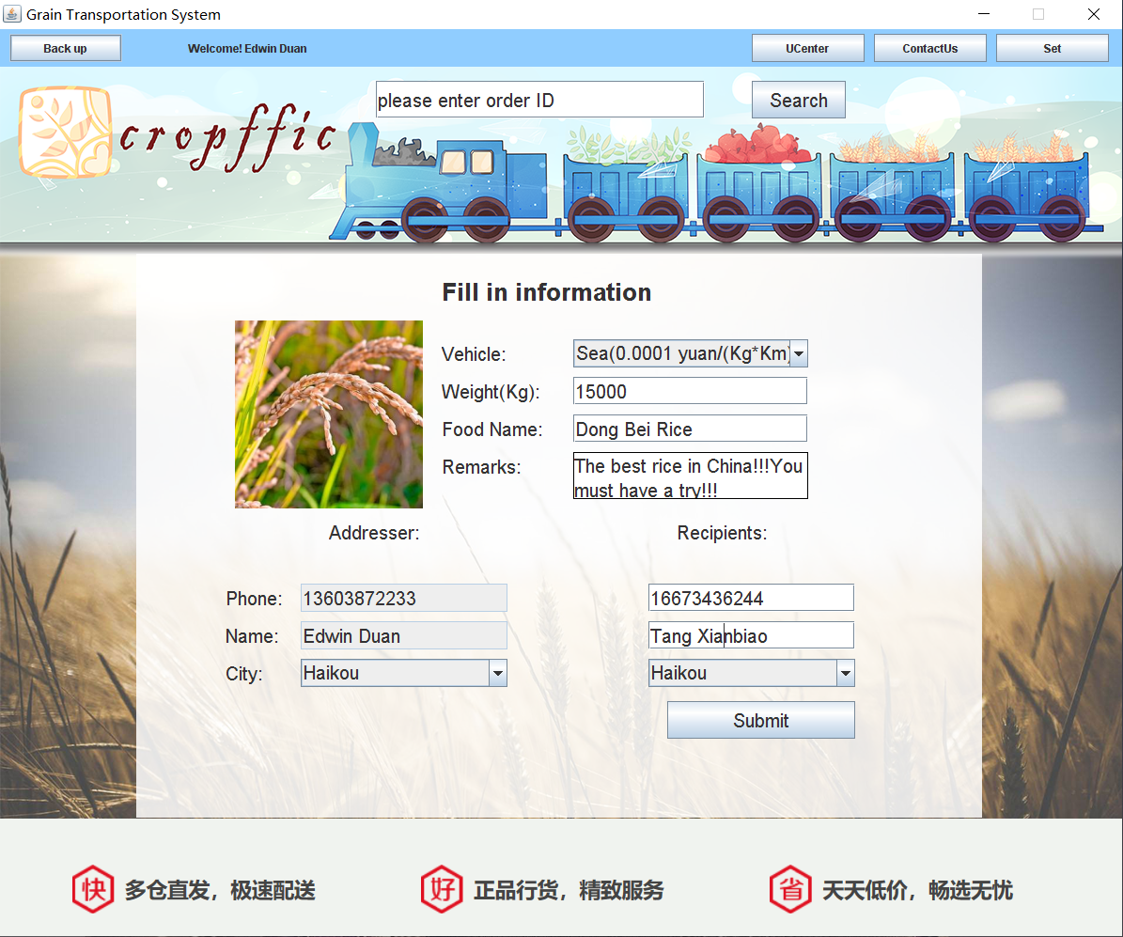

**The goods can’t be sent to the same city**

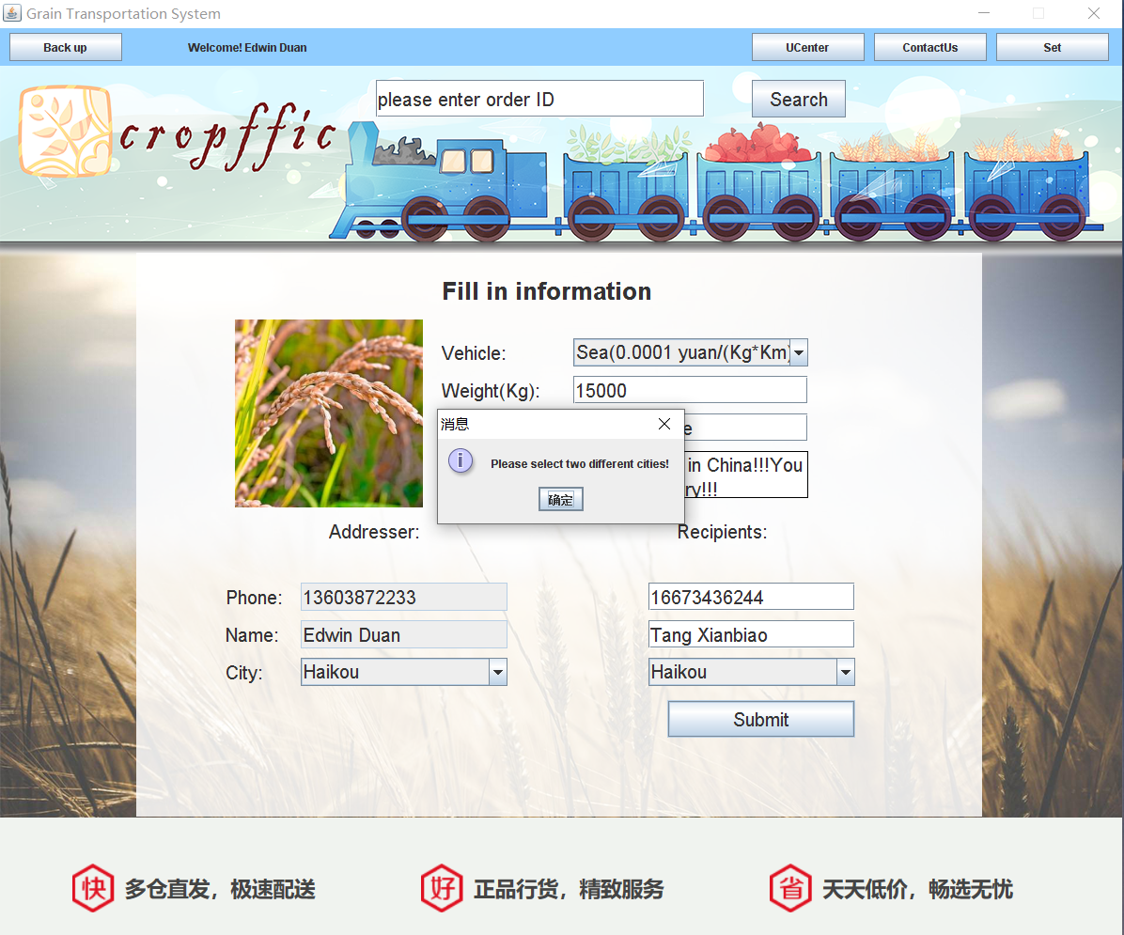

**Payment Module（Ocean Transportation）**



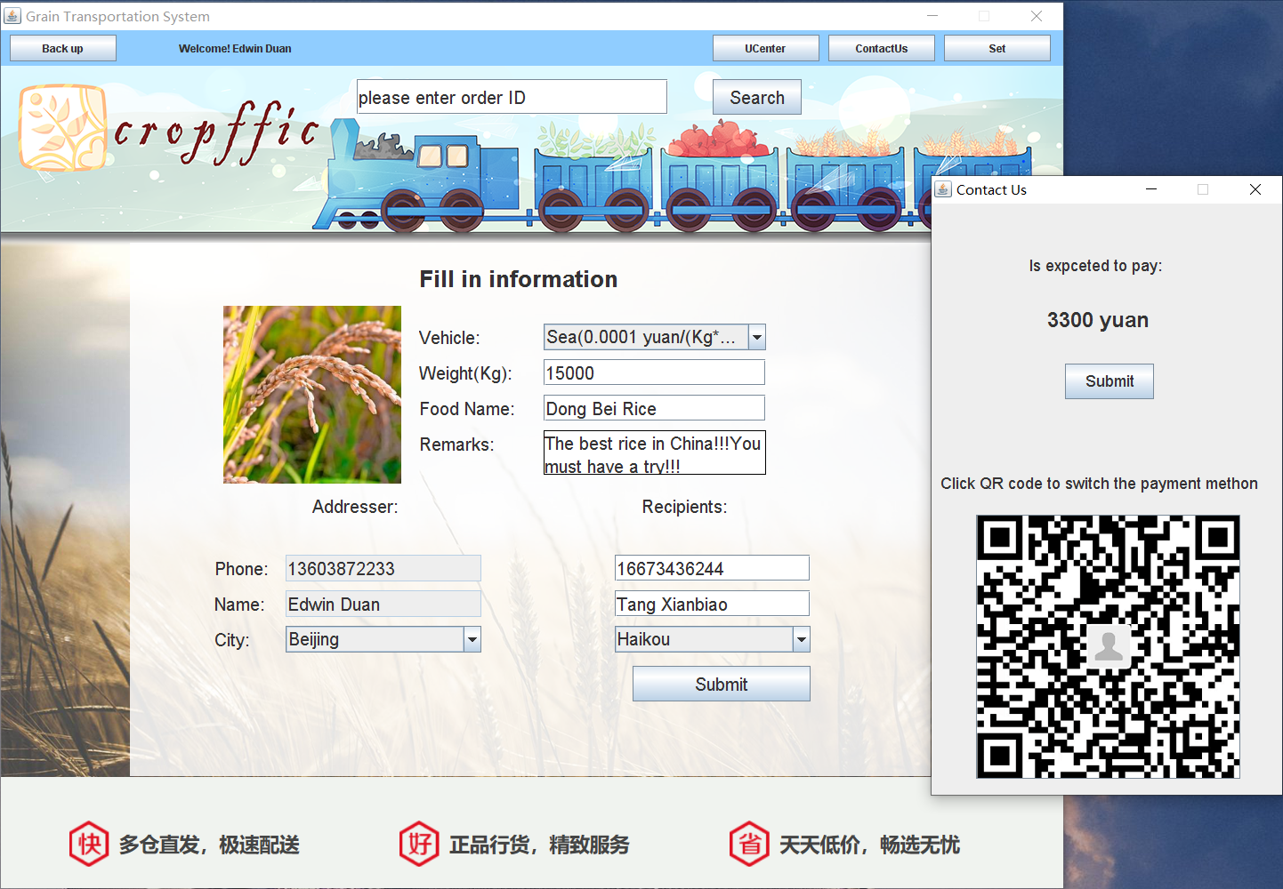

**Get the order number for your goods（Ocean Transportation）**

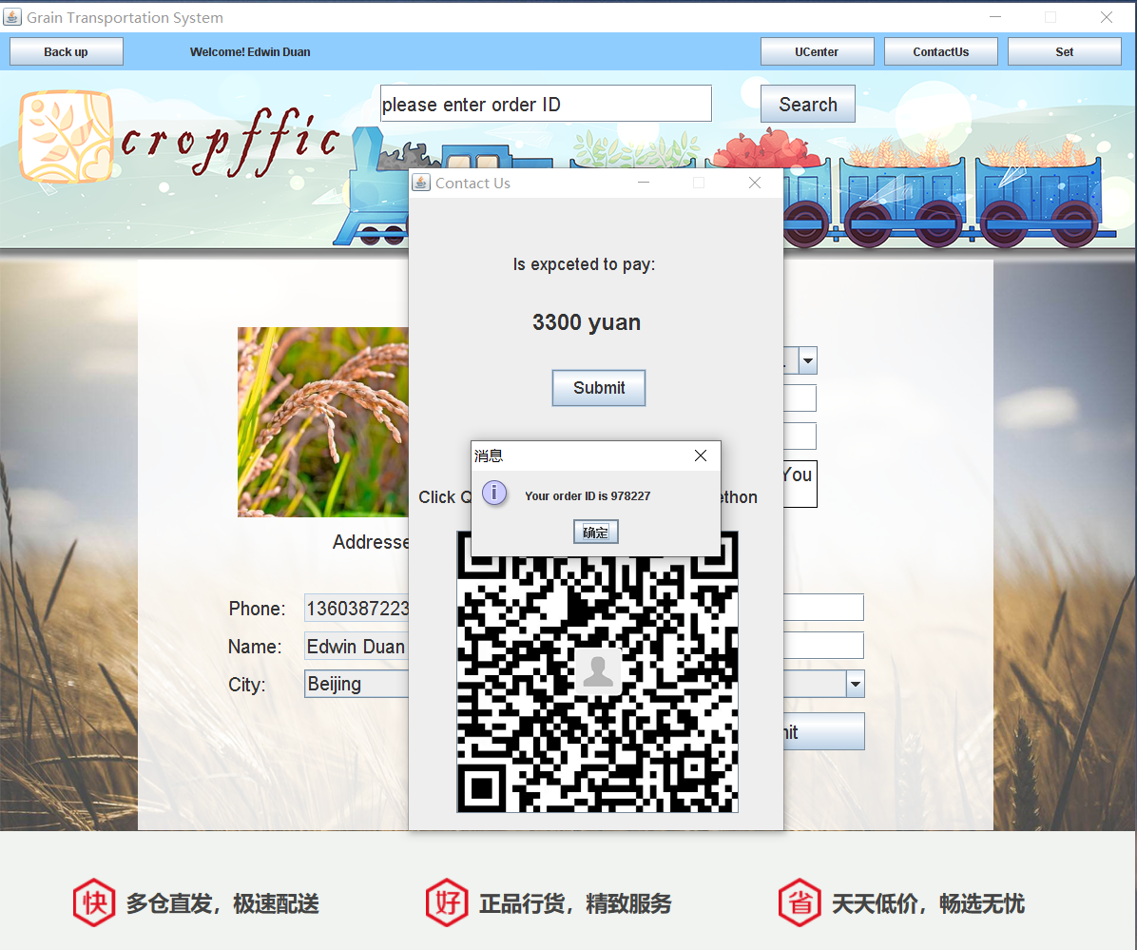

**The BFTZ Company Invoice(Sea Transportation)**

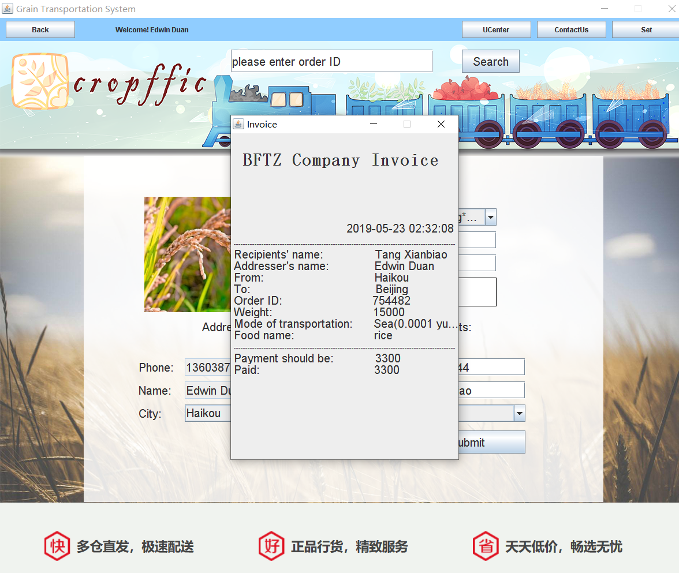

**Payment Module（Land Transportation）**

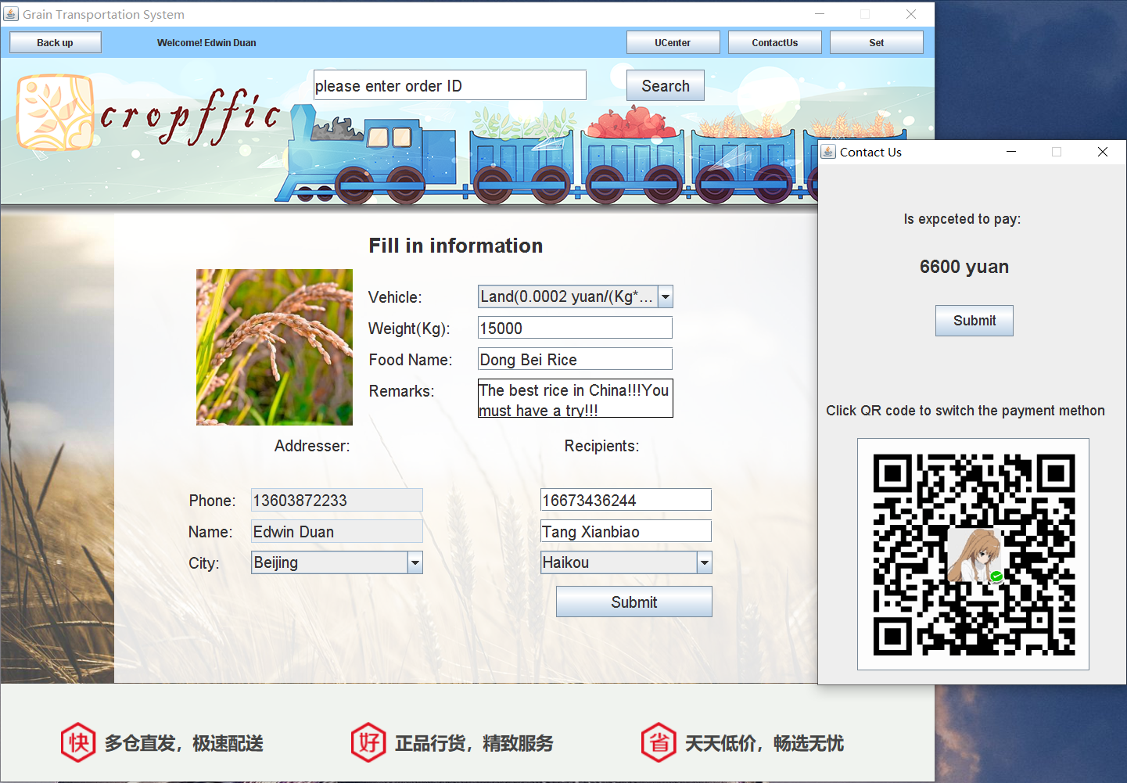

**Get the order number for your goods（Land Transportation）**

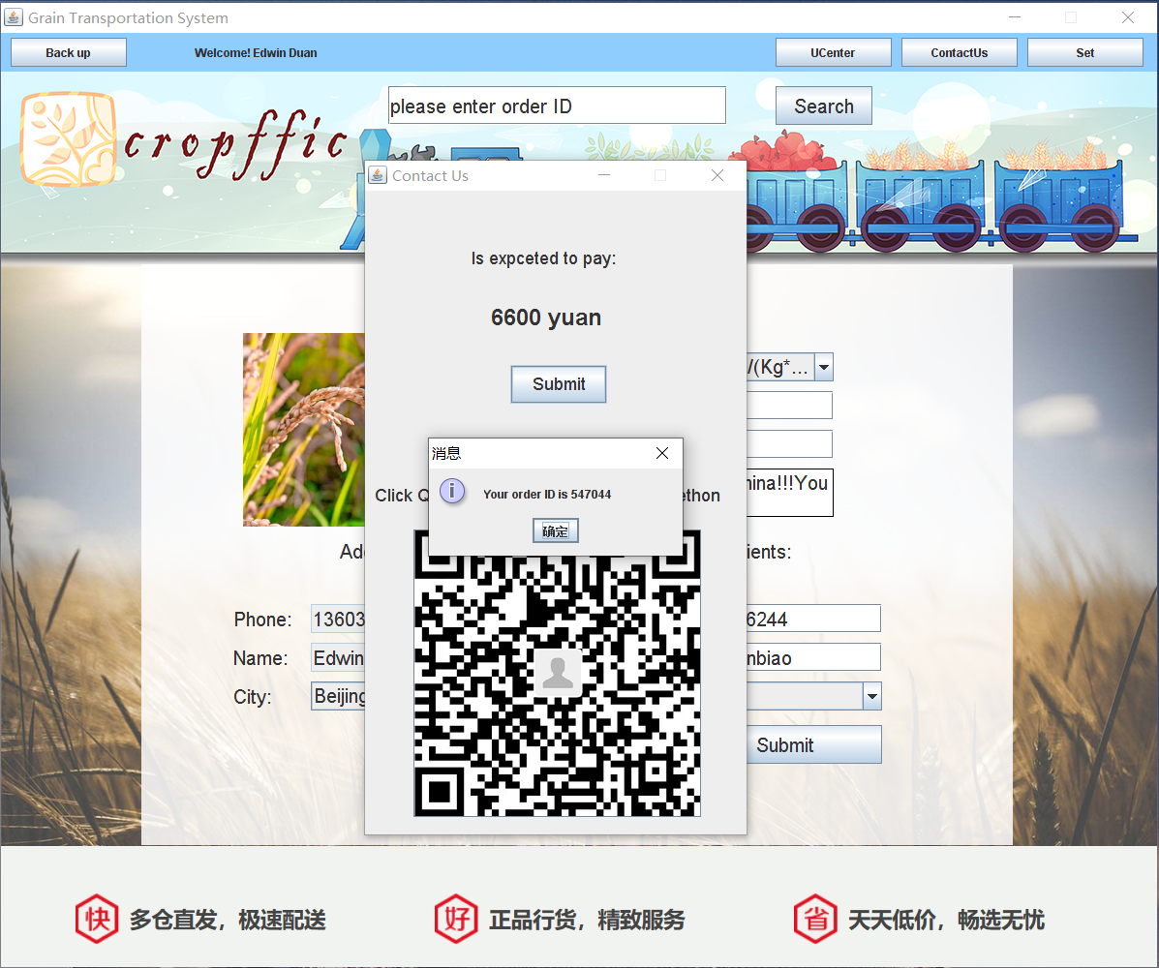

**The BFTZ Company Invoice(Land Transportation)**

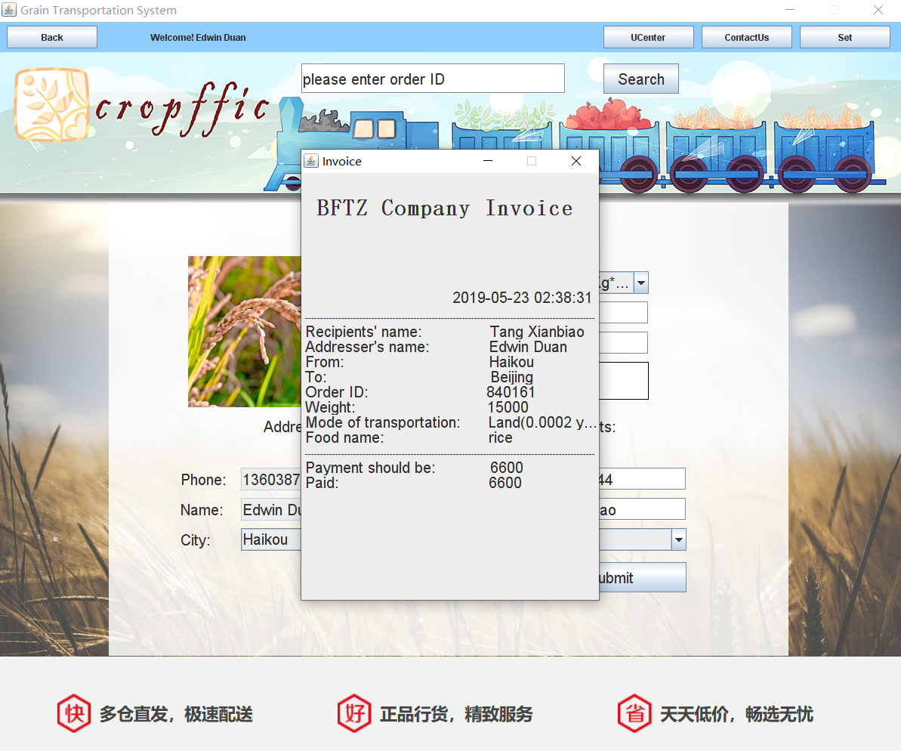

**Payment Module（Air Transportation）**

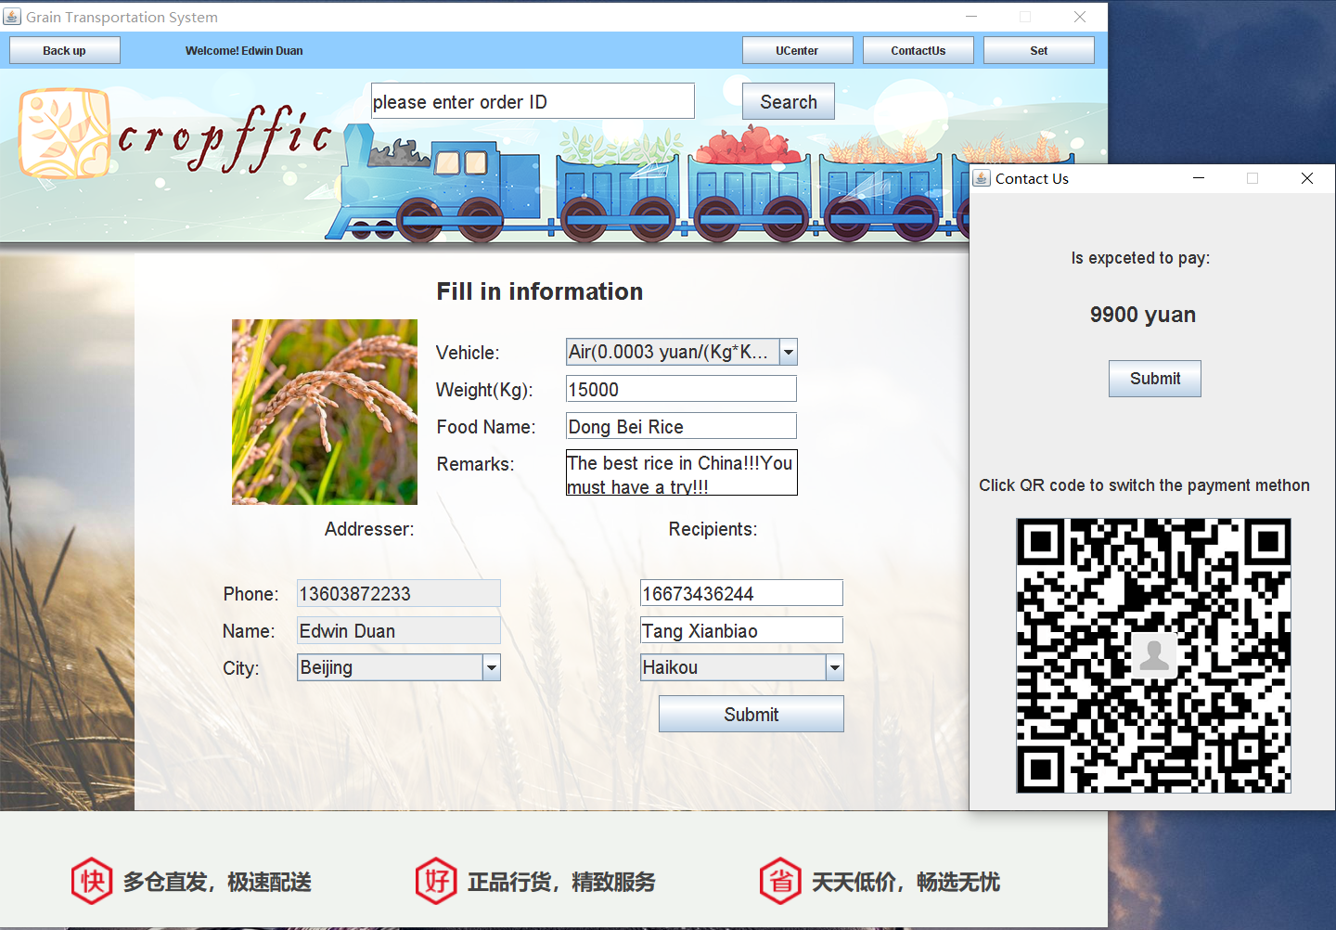

**Get the order number for your goods（Air Transportation）**

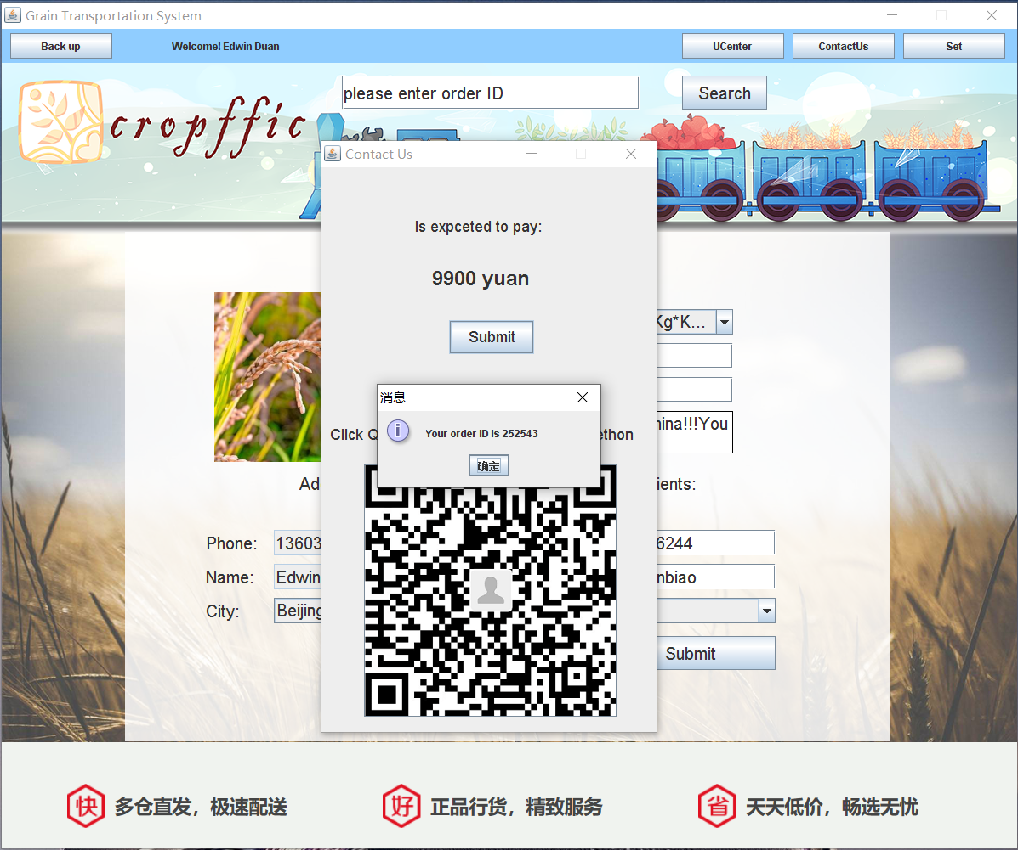

**The BFTZ Company Invoice(Air Transportation)**

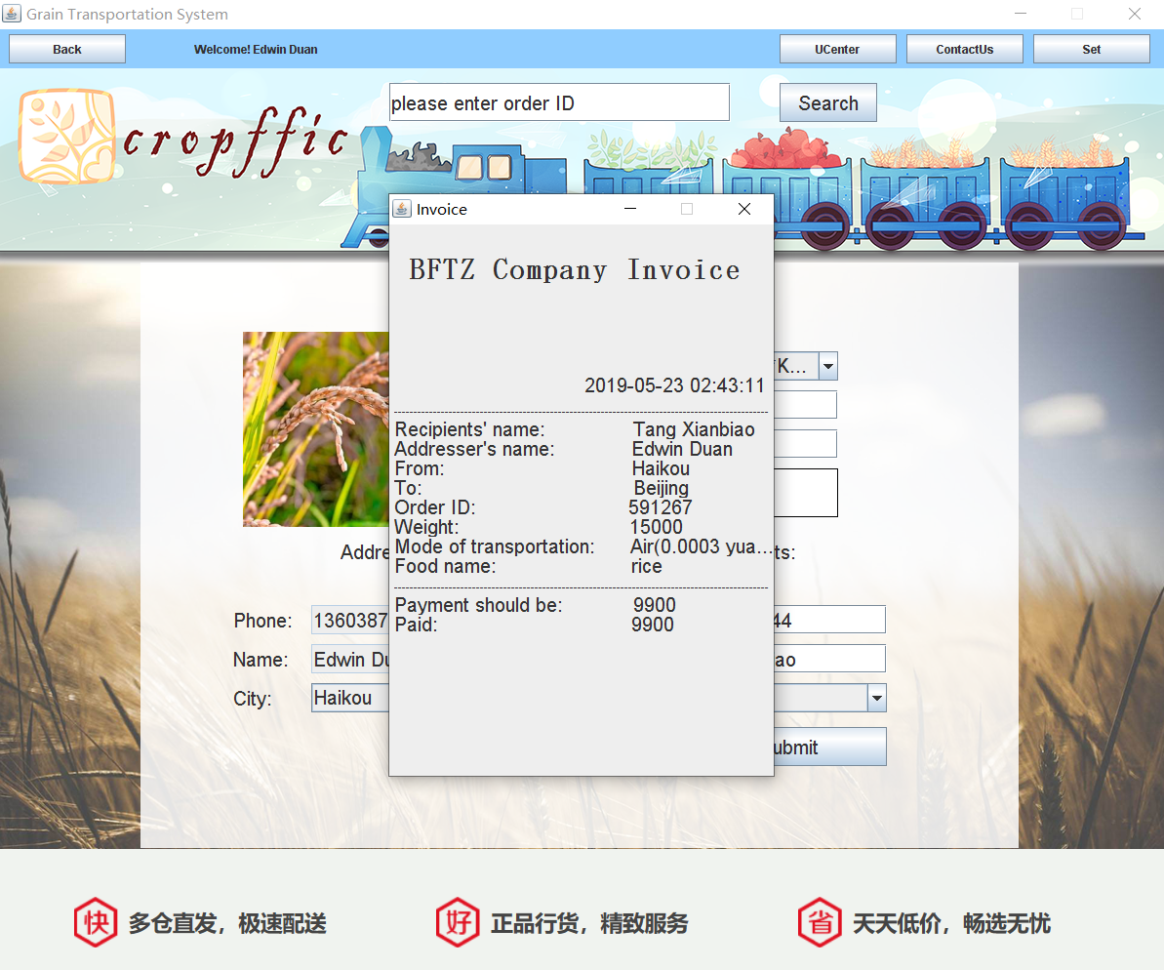

**Deliver.java**

package niitprojcet;

import java.awt.Color;

import java.awt.Font;

import java.awt.event.*;

import java.sql.Connection;

import java.sql.PreparedStatement;

import java.sql.ResultSet;

import java.sql.SQLException;

import javax.swing.*;

import java.util.*;

public class Deliver extends JFrame implements ActionListener, MouseListener {

public void GUI() {

Font font = new Font("a", Font.PLAIN, 20);

jltRName2 = new JLabel(" receiver's name");

jltRName2.setVisible(false);

jltRName2.setBounds(760, 390, 140, 30);

jltRName1 = new JLabel("Please enter the");

jltRName1.setVisible(false);

jltRName1.setBounds(760, 350, 140, 30);

jltRPhone3 = new JLabel(" number");

jltRPhone3.setVisible(false);

jltRPhone3.setBounds(760, 430, 140, 30);

jltRPhone1 = new JLabel("receiver's telephone");

jltRPhone1.setVisible(false);

jltRPhone1.setBounds(760, 390, 140, 30);

jltRPhone2 = new JLabel("Please enter the");

jltRPhone2.setVisible(false);

jltRPhone2.setBounds(760, 350, 140, 30);

jltRemarks2 = new JLabel(" of the goods");

jltRemarks2.setVisible(false);

jltRemarks2.setBounds(720, 250, 190, 30);

jltRemarks1 = new JLabel("Please enter information");

jltRemarks1.setVisible(false);

jltRemarks1.setBounds(720, 220, 190, 30);

jltName = new JLabel("Please enter what you send");

jltName.setVisible(false);

jltName.setBounds(720, 170, 190, 30);

jltWight = new JLabel("Please send less than 10⁶KG");

jltWight.setVisible(false);

jltWight.setBounds(720, 130, 190, 30);

jlAsk = new JLabel("Fill in information");

jlAsk.setBounds(320, 20, 260, 40);

jlAsk.setFont(new Font("Arial", Font.BOLD, 26));

jlType = new JLabel("Vehicle:");

jlType.setBounds(320, 90, 120, 30);

jlType.setFont(font);

jcbType = new JComboBox();

jcbType.setBounds(460, 90, 250, 30);

jcbType.setFont(font);

jcbType.addItem("Sea(0.0001 yuan/(Kg*Km))");

jcbType.addItem("Land(0.0002 yuan/(Kg*Km))");

jcbType.addItem("Air(0.0003 yuan/(Kg*Km))");

jlWeight = new JLabel("Weight(Kg):");

jlWeight.setBounds(320, 130, 120, 30);

jlWeight.setFont(font);

jtfWeight = new JTextField();

jtfWeight.setBounds(460, 130, 250, 30);

jtfWeight.setFont(font);

jtfWeight.addMouseListener(this);

jlHName = new JLabel("Food Name:");

jlHName.setBounds(320, 170, 120, 30);

jlHName.setFont(font);

jtfHName = new JTextField();

jtfHName.setBounds(460, 170, 250, 30);

jtfHName.setFont(font);

jtfHName.addMouseListener(this);

jlRemark = new JLabel("Remarks:");

jlRemark.setBounds(320, 210, 120, 30);

jlRemark.setFont(font);

// contentPane.add(textArea);

jtaRemark = new JTextArea();

jtaRemark.setBounds(460, 210, 250, 50);

jtaRemark.setLineWrap(true);

jtaRemark.setWrapStyleWord(true);

jtaRemark.setFont(font);

jtaRemark.setBorder(BorderFactory.createLineBorder(Color.BLACK));

jtaRemark.addMouseListener(this);

scrollPane_1 = new JScrollPane(jtaRemark);

scrollPane_1.setBounds(460, 210, 250, 50);

scrollPane_1.setHorizontalScrollBarPolicy(

JScrollPane.HORIZONTAL_SCROLLBAR_ALWAYS);

scrollPane_1.setVerticalScrollBarPolicy(

JScrollPane.VERTICAL_SCROLLBAR_ALWAYS);

jlAdr = new JLabel("Addresser:");

jlAdr.setFont(font);

jlAdr.setBounds(200, 280, 130, 30);

jlRec = new JLabel("Recipients:");

jlRec.setFont(font);

jlRec.setBounds(570, 280, 130, 30);

jlID = new JLabel("Phone:");

jlID.setFont(font);

jlID.setBounds(90, 350, 130, 30);

jtfID1 = new JTextField();

jtfID1.setFont(font);

jtfID1.setBounds(170, 350, 220, 30);

jtfID1.setText(Login.Phone);

jtfID1.setEditable(false);

jtfID1.addMouseListener(this);

jtfID2 = new JTextField();

jtfID2.setFont(font);

jtfID2.setBounds(540, 350, 220, 30);

jtfID2.addMouseListener(this);

jlName = new JLabel("Name:");

jlName.setFont(font);

jlName.setBounds(90, 390, 60, 30);

jtfName1 = new JTextField();

jtfName1.setFont(font);

jtfName1.setBounds(170, 390, 220, 30);

jtfName1.setText(Login.Name);

jtfName1.setEditable(false);

jtfName1.addMouseListener(this);

jtfName2 = new JTextField();

jtfName2.setFont(font);

jtfName2.setBounds(540, 390, 220, 30);

jtfName2.addMouseListener(this);

jlCity = new JLabel("City:");

jlCity.setFont(font);

jlCity.setBounds(90, 430, 60, 30);

jcbCity1 = new JComboBox();

jcbCity1.setFont(font);

jcbCity1.setBounds(170, 430, 220, 30);

jcbCity1.addItem("Haikou");

jcbCity1.addItem("Beijing");

jcbCity1.addItem("Shanghai");

jcbCity1.addItem("Guangzhou");

jcbCity2 = new JComboBox();

jcbCity2.setFont(font);

jcbCity2.setBounds(540, 430, 220, 30);

jcbCity2.addItem("Haikou");

jcbCity2.addItem("Beijing");

jcbCity2.addItem("Shanghai");

jcbCity2.addItem("Guangzhou");

jbSubmit = new JButton("Submit");

jbSubmit.setFont(font);

jbSubmit.setBounds(560, 475, 200, 40);

jbSubmit.addActionListener(this);

jlPic1 = new JLabel(new ImageIcon(getClass().getResource("/pic/p1.png")));

jlPic1.setBounds(100, 70, 200, 200);

jpMain = new JLayeredPane();

jpMain.setLayout(null);

jpMain.setBounds(150, 200, 900, 600);

jpMain.add(jlID);

jpMain.add(jtfID1);

jpMain.add(jtfID2);

jpMain.add(jlName);

jpMain.add(jtfName1);

jpMain.add(jtfName2);

jpMain.add(jlCity);

jpMain.add(jcbCity1);

jpMain.add(jcbCity2);

jpMain.add(jlAdr);

jpMain.add(jlRec);

jpMain.add(jbSubmit);

jpMain.add(jlAsk);

jpMain.add(jlType);

jpMain.add(jcbType);

jpMain.add(jlWeight);

jpMain.add(jtfWeight);

jpMain.add(jlHName);

jpMain.add(jtfHName);

jpMain.add(jlRemark);

jpMain.add(jtaRemark);

jpMain.add(scrollPane_1);

jpMain.add(jlPic1);

jpMain.add(jltWight);

jpMain.add(jltName);

jpMain.add(jltRemarks1);

jpMain.add(jltRemarks2);

jpMain.add(jltRPhone1);

jpMain.add(jltRPhone2);

jpMain.add(jltRPhone3);

jpMain.add(jltRName1);

jpMain.add(jltRName2);

jtfSearch = new JTextField();

jtfSearch.setFont(font);

jtfSearch.setBounds(400, 15, 350, 40);

jtfSearch.setText("please enter order ID");

jbSearch = new JButton("Search");

jbSearch.setFont(font);

jbSearch.setBounds(800, 15, 100, 40);

jbSearch.addActionListener(this);

jlGround = new JLabel();

jlGround.setBounds(0, 0, 1200, 800);

jlGround.setIcon(new ImageIcon(getClass().getResource("/pic/网页背景2.png")));

jlpBig = new JLayeredPane();

jlpBig.setLayout(null);

jlpBig.setBackground(Color.YELLOW);

jlpBig.setBounds(0, 40, 1200, 800);

jlpBig.add(jtfSearch);

jlpBig.add(jbSearch);

jlpBig.add(jpMain);

jlpBig.add(jlGround, -1);

//下面一部分

jlDown = new JLabel();

jlDown.setIcon(new ImageIcon(getClass().getResource("/pic/Down.png")));

jlDown.setBounds(0, 0, 1200, 160);

jpDown = new JPanel();

jpDown.setLayout(null);

jpDown.setBounds(0, 840, 1200, 160);

jpDown.setBackground(Color.GREEN);

jpDown.add(jlDown);

//上面一部分

jbBack = new JButton("Back");

jbBack.setBounds(10, 5, 120, 30);

jbBack.addActionListener(this);

jlUserName = new JLabel("Welcome! " + Login.Name);

jlUserName.setBounds(200, 0, 250, 40);

jbUCenter = new JButton("UCenter");

jbUCenter.setBounds(800, 5, 120, 30);

jbUCenter.addActionListener(this);

jbContactUs = new JButton("ContactUs");

jbContactUs.setBounds(930, 5, 120, 30);

jbContactUs.addActionListener(this);

jbSet = new JButton("Set");

jbSet.setBounds(1060, 5, 120, 30);

jbSet.addActionListener(this);

jpUp = new JPanel();

jpUp.setLayout(null);

jpUp.setBounds(0, 0, 1200, 40);

jpUp.setBackground(new Color(144, 205, 255));

jpUp.add(jbBack);

jpUp.add(jbUCenter);

jpUp.add(jbSet);

jpUp.add(jbContactUs);

jpUp.add(jlUserName);

jf = new JFrame("Grain Transportation System");

jf.setDefaultCloseOperation(WindowConstants.DO_NOTHING_ON_CLOSE);

jf.addWindowListener(new WindowAdapter() {

@Override

public void windowClosing(WindowEvent e) {

int option = JOptionPane.showConfirmDialog(Deliver.this, "exit?", "提示", JOptionPane.YES_NO_OPTION);

if (option == JOptionPane.YES_OPTION) {

System.exit(0);

}

}

});

jf.setResizable(false);

jf.setSize(1200, 1000);

jf.setVisible(true);

jf.setLocationRelativeTo(null);

jf.setLayout(null);

jf.add(jpUp);

jf.add(jlpBig);

jf.add(jpDown);

}

public static void main(String[] args) {

new Deliver().GUI();

}

public static int juli, orderID, s;

public static int weight, price;

public static int X1, Y1, X2, Y2;

public static String ID1, Name1, ID2, Name2, City1, City2, Cargo_Infor, Cargo_Name, type;

public static String phone1, phone2, name1, name2;

private JFrame jf;

private JPanel jpUp, jpDown;

private JLayeredPane jlpBig, jpMain;

private JButton jbUCenter, jbContactUs, jbSet, jbSearch, jbBack, jbSubmit;

private JLabel jlGround, jlUserName, jlDown, jlPic1, jlAdr, jlRec, jlType,

jlHName, jlWeight, jlRemark, jlAsk, jlID, jlName, jlCity,

jltWight, jltName, jltRemarks1, jltRemarks2, jltRPhone1, jltRPhone2, jltRPhone3, jltRName1, jltRName2;

private JTextField jtfSearch, jtfID1, jtfID2, jtfName1, jtfName2, jtfHName, jtfWeight;

private JTextArea jtaRemark;

private JComboBox jcbCity1, jcbCity2, jcbType;

private JScrollPane scrollPane_1;

@Override

public void actionPerformed(ActionEvent e) {

if (e.getSource() == jbUCenter) {

// JOptionPane.showMessageDialog(jf, "This function is not currently on……");

Self_centery s = new Self_centery();

jf.dispose();

s.GUI();

}

if (e.getSource() == jbSet) {

JOptionPane.showMessageDialog(jf, "This function is not currently on……");

}

if (e.getSource() == jbBack) {

jf.dispose();

Main main = new Main();

main.GUI();

new Thread(main).start();

}

if (e.getSource() == jbContactUs) {

ContactUs contactUs = new ContactUs();

}

if (e.getSource() == jbSearch) {

if (jtfSearch.getText().length() > 0) {

Main.orderID = jtfSearch.getText();

Connection con = null;

PreparedStatement ps = null;

ResultSet rs = null;

try {

con = DBUtil.getConnection();

String sql = "select * from Order_forms where Order_id=?";

ps = con.prepareStatement(sql);

ps.setString(1, jtfSearch.getText());

rs = ps.executeQuery();

if (rs.next()) {

Main.HName = rs.getString(8);

Main.Info = rs.getString(9);

Main.ID1 = rs.getString(2);

Main.Name1 = rs.getString(3);

Main.City1 = rs.getString(4);

Main.ID2 = rs.getString(5);

Main.Name2 = rs.getString(6);

Main.City2 = rs.getString(7);

Main.Arr = rs.getString(13);

Main.Price = rs.getInt(11);

Main.Type = rs.getString(10);

Main.Flag = 1;

} else {

Main.Flag = 0;

}

sql = "select * from Citys where city_Name=?";

ps = con.prepareStatement(sql);

ps.setString(1, Main.City1);

rs = ps.executeQuery();

while (rs.next()) {

Main.X1 = rs.getInt(4);

Main.Y1 = rs.getInt(5);

}

sql = "select * from Citys where City_name=?";

ps = con.prepareStatement(sql);

ps.setString(1, Main.City2);

rs = ps.executeQuery();

while (rs.next()) {

Main.X2 = rs.getInt(4);

Main.Y2 = rs.getInt(5);

}

jf.dispose();

new Search().GUI();

} catch (SQLException ex) {

JOptionPane.showMessageDialog(jf, ex);

} finally {

try {

rs.close();

ps.close();

con.close();

} catch (SQLException ex) {

JOptionPane.showMessageDialog(jf, ex);

}

}

}

}

if (e.getSource() == jbSubmit) {

if (jtfWeight.getText().length() == 0 || jtfHName.getText().length() == 0

|| jtaRemark.getText().length() == 0

|| jtfID2.getText().length() == 0

|| jtfName2.getText().length() == 0) {

JOptionPane.showMessageDialog(jf, "Please enter full information!");

} else if (jcbCity1.getSelectedIndex() == jcbCity2.getSelectedIndex()) {

JOptionPane.showMessageDialog(jf, "Please select two different cities!");

} else {

boolean flag2 = true;

try {

weight = Integer.parseInt(jtfWeight.getText());

if (weight <= 1000 || weight > 1000000) {

weight = weight / 0;

}

} catch (Exception ex) {

JOptionPane.showMessageDialog(jf, "Weight must be a integer and between 1000 and 1000000 ");

flag2 = false;

}

if (flag2) {

Connection con = null;

PreparedStatement ps = null;

ResultSet rs = null;

try {

con = DBUtil.getConnection();

String sql = "select 1 from Users where User_phone=?";

ps = con.prepareStatement(sql);

ps.setString(1, jtfID2.getText());

rs = ps.executeQuery();

{

if (!rs.next()) {

JOptionPane.showMessageDialog(jf, "Recipient's ID does not exist");

} else {

sql = "select * from Citys where city_Id=?";

ps = con.prepareStatement(sql);

ps.setInt(1, jcbCity1.getSelectedIndex());

rs = ps.executeQuery();

while (rs.next()) {

X1 = rs.getInt(4);

Y1 = rs.getInt(5);

}

sql = "select * from Citys where city_Id=?";

ps = con.prepareStatement(sql);

ps.setInt(1, jcbCity2.getSelectedIndex());

rs = ps.executeQuery();

while (rs.next()) {

X2 = rs.getInt(4);

Y2 = rs.getInt(5);

}

Deliver.orderID = new Random().nextInt(900001) + 100000;

juli(jcbCity1.getSelectedIndex() + 1, jcbCity2.getSelectedIndex() + 1);

price = weight * (jcbType.getSelectedIndex() + 1) * juli / 10000;

ID1 = jtfID1.getText();

ID2 = jtfID2.getText();

Name1 = jtfName1.getText();

Name2 = jtfName2.getText();

City1 = (String) jcbCity1.getSelectedItem();

City2 = (String) jcbCity2.getSelectedItem();

Cargo_Name = jtfHName.getText();

Cargo_Infor = jtaRemark.getText();

type = (String) jcbType.getSelectedItem();

s = jcbType.getSelectedIndex();

Payment payment = new Payment();

}

}

} catch (Exception ex1) {

JOptionPane.showMessageDialog(jf, "Please enter the correct information");

} finally {

try {

rs.close();

ps.close();

con.close();

} catch (SQLException ex) {

JOptionPane.showMessageDialog(jf, "Please enter the correct information");

}

}

}

}

}

}

private void juli(int a, int b) {

if ((a == 1 && b == 2) || (a == 2 && b == 1)) {

juli = 2200;

}

if ((a == 1 && b == 3) || (a == 3 && b == 1)) {

juli = 1700;

}

if ((a == 1 && b == 4) || (a == 4 && b == 1)) {

juli = 460;

}

if ((a == 2 && b == 3) || (a == 3 && b == 2)) {

juli = 1100;

}

if ((a == 2 && b == 4) || (a == 4 && b == 2)) {

juli = 1900;

}

if ((a == 3 && b == 4) || (a == 4 && b == 3)) {

juli = 1200;

}

}

@Override

public void mouseClicked(MouseEvent e) {

}

@Override

public void mousePressed(MouseEvent e) {

}

@Override

public void mouseReleased(MouseEvent e) {

}

@Override

public void mouseEntered(MouseEvent e) {

if (e.getSource() == jtfWeight) {

jltWight.setVisible(true);

}

if (e.getSource() == jltName) {

jltName.setVisible(true);

}

if (e.getSource() == jtaRemark) {

jltRemarks1.setVisible(true);

}

if (e.getSource() == jtaRemark) {

jltRemarks2.setVisible(true);

}

if (e.getSource() == jtfID2) {

jltRPhone1.setVisible(true);

}

if (e.getSource() == jtfID2) {

jltRPhone2.setVisible(true);

}

if (e.getSource() == jtfID2) {

jltRPhone3.setVisible(true);

}

if (e.getSource() == jtfName2) {

jltRName1.setVisible(true);

}

if (e.getSource() == jtfName2) {

jltRName2.setVisible(true);

}

}

// private JTextField jtfSearch, jtfID1, jtfID2, jtfName1, jtfName2, jtfHName, jtfWeight;

// jltWight,jltName,jltRemarks,jltSPhone,jltSName,jltRPhone,jltRName;

@Override

public void mouseExited(MouseEvent e) {

if (e.getSource() == jtfWeight) {

jltWight.setVisible(false);

}

if (e.getSource() == jltName) {

jltName.setVisible(false);

}

if (e.getSource() == jtaRemark) {

jltRemarks1.setVisible(false);

}

if (e.getSource() == jtaRemark) {

jltRemarks2.setVisible(false);

}

if (e.getSource() == jtfID2) {

jltRPhone1.setVisible(false);

}

if (e.getSource() == jtfID2) {

jltRPhone2.setVisible(false);

}

if (e.getSource() == jtfID2) {

jltRPhone3.setVisible(false);

}

if (e.getSource() == jtfName2) {

jltRName1.setVisible(false);

}

if (e.getSource() == jtfName2) {

jltRName2.setVisible(false);

}

}

}

**Payment.java**

package niitprojcet;

import java.util.Date;

import java.sql.*;

import java.awt.Font;

import java.awt.event.ActionEvent;

import java.awt.event.ActionListener;

import java.awt.event.WindowAdapter;

import java.awt.event.WindowEvent;

import java.sql.ResultSet;

import java.sql.SQLException;

import java.util.Random;

import java.util.logging.Level;

import java.util.logging.Logger;

import javax.swing.*;

import java.util.*;

public class Payment extends JFrame implements ActionListener {

public Payment() {

Font font = new Font("Arial", Font.PLAIN, 18);

jl3 = new JLabel("Click QR code to switch the payment methon");

jl3.setBounds(10, 300, 380, 30);

jl3.setFont(font);

jb2 = new JButton(new ImageIcon(getClass().getResource("/pic/Alipay.png")));

jb2.setBounds(50, 350, 297, 297);

jb2.addActionListener(this);

jl1 = new JLabel("Is expceted to pay:");

jl1.setBounds(110, 50, 180, 40);

jl1.setFont(font);

jl2 = new JLabel(Deliver.price + " yuan");

jl2.setBounds(130, 110, 240, 40);

jl2.setFont(new Font("a", Font.BOLD, 24));

jb = new JButton("Submit");

jb.setBounds(150, 180, 100, 40);

jb.setFont(font);

jb.addActionListener(this);

jp = new JPanel();

jp.setLayout(null);

jp.setBounds(0, 0, 400, 700);

jp.add(jl1);

jp.add(jl2);

jp.add(jb);

jp.add(jb2);

jp.add(jl3);

jf = new JFrame("Payment");

jf.setDefaultCloseOperation(WindowConstants.DO_NOTHING_ON_CLOSE);

jf.addWindowListener(new WindowAdapter() {

@Override

public void windowClosing(WindowEvent e) {

int option = JOptionPane.showConfirmDialog(Payment.this, "Cancel?", "提示", JOptionPane.YES_NO_OPTION);

if (option == JOptionPane.YES_OPTION) {

jf.dispose();

}

}

});

jf.setResizable(false);

jf.setSize(400, 700);

jf.setVisible(true);

jf.setLocationRelativeTo(null);

jf.setLayout(null);

jf.add(jp);

}

public static void main(String[] args) {

Payment payment = new Payment();

}

private JFrame jf;

private JPanel jp;

private JLabel jl1, jl2, jl3;

private JButton jb, jb2;

private static int x = 1;

@Override

public void actionPerformed(ActionEvent e) {

if (e.getSource() == jb2) {

if (x == 1) {

jb2.setIcon(new ImageIcon(getClass().getResource("/pic/Wechat.png")));

x = 0;

} else {

jb2.setIcon(new ImageIcon(getClass().getResource("/pic/Alipay.png")));

x = 1;

}

}

if (e.getSource() == jb) {

Connection con = null;

PreparedStatement ps = null;

try {

con = (Connection) DBUtil.getConnection();

String sql = "insert into order_forms values(?,?,?,?,?,?,?,?,?,?,?,?,'No')";

ps = (PreparedStatement) con.prepareStatement(sql);

ps.setString(1, Integer.toString(Deliver.orderID));

ps.setLong(2, Long.parseLong(Deliver.ID1));

ps.setString(3, Deliver.Name1);

ps.setString(4, Deliver.City1);

ps.setLong(5, Long.parseLong(Deliver.ID2));

ps.setString(6, Deliver.Name2);

ps.setString(7, Deliver.City2);

ps.setString(8, Deliver.Cargo_Name);

ps.setString(9, Deliver.Cargo_Infor);

ps.setString(10, Deliver.type);

ps.setInt(11, Deliver.price);

java.sql.Date time = new java.sql.Date(new Date().getTime());

ps.setDate(12, time);

ps.execute();

JOptionPane.showMessageDialog(jf, "Your order ID is " + Deliver.orderID);

jf.dispose();

new Fapiao().GUI();

} catch (Exception ex) {

JOptionPane.showMessageDialog(jf, "Please don't repeat the click");

} finally {

try {

ps.close();

con.close();

} catch (SQLException ex) {

JOptionPane.showMessageDialog(jf, ex);

}

}

}

}

}

**Fapiao.java**

package niitprojcet;

import com.mysql.jdbc.Connection;

import com.mysql.jdbc.PreparedStatement;

import java.awt.Font;

import java.awt.event.WindowAdapter;

import java.awt.event.WindowEvent;

import java.sql.ResultSet;

import java.sql.SQLException;

import java.text.SimpleDateFormat;

import java.util.Date;

import java.util.logging.Level;

import java.util.logging.Logger;

import javax.swing.*;

public class Fapiao {

public void GUI() {

Font font = new Font("Arial", Font.PLAIN, 20);

jlTitle = new JLabel("BFTZ Company Invoice");

jlTitle.setFont(new Font("宋体", Font.BOLD, 30));

jlTitle.setBounds(20, 20, 360, 50);

jlTime = new JLabel(new SimpleDateFormat("yyyy-MM-dd HH:mm:ss").format(new Date()));

jlTime.setBounds(200, 150, 200, 30);

jlTime.setFont(font);

jlFen1 = new JLabel("------------------------------------------------------------------------------------------------");

jlFen1.setBounds(5, 180, 390, 20);

jlShou = new JLabel("Recipients' name: " + Deliver.Name2);

jlShou.setBounds(5, 200, 390, 20);

jlShou.setFont(font);

jlFa = new JLabel("Addresser's name: " + Deliver.Name1);

jlFa.setBounds(5, 220, 390, 20);

jlFa.setFont(font);

jlCity1 = new JLabel("From: " + Deliver.City1);

jlCity1.setBounds(5, 240, 390, 20);

jlCity1.setFont(font);

jlCity2 = new JLabel("To: " + Deliver.City2);

jlCity2.setBounds(5, 260, 390, 20);

jlCity2.setFont(font);

jlOrder = new JLabel("Order ID: " + Deliver.orderID);

jlOrder.setBounds(5, 280, 390, 20);

jlOrder.setFont(font);

jlWeight = new JLabel("Weight: " + Deliver.weight);

jlWeight.setBounds(5, 300, 390, 20);

jlWeight.setFont(font);

jlType = new JLabel("Mode of transportation: " + Deliver.type);

jlType.setBounds(5, 320, 390, 20);

jlType.setFont(font);

jlName = new JLabel("Food name: " + Deliver.Cargo_Name);

jlName.setBounds(5, 340, 390, 20);

jlName.setFont(font);

jlFen2 = new JLabel("------------------------------------------------------------------------------------------------");

jlFen2.setBounds(5, 360, 390, 20);

jlMoney1 = new JLabel("Payment should be: " + Deliver.price);

jlMoney1.setBounds(5, 380, 390, 20);

jlMoney1.setFont(font);

jlMoney2 = new JLabel("Paid: " + Deliver.price);

jlMoney2.setBounds(5, 400, 390, 20);

jlMoney2.setFont(font);

jf = new JFrame("Invoice");

jf.setDefaultCloseOperation(WindowConstants.DISPOSE_ON_CLOSE);

jf.setResizable(false);

jf.setSize(400, 600);

jf.setVisible(true);

jf.setLocationRelativeTo(null);

jf.setLayout(null);

jf.add(jlTitle);

jf.add(jlFen1);

jf.add(jlFen2);

jf.add(jlCity1);

jf.add(jlCity2);

jf.add(jlShou);

jf.add(jlFa);

jf.add(jlName);

jf.add(jlOrder);

jf.add(jlWeight);

jf.add(jlType);

jf.add(jlMoney1);

jf.add(jlMoney2);

jf.add(jlTime);

}

public static void main(String[] args) {

new Fapiao().GUI();

}

private JFrame jf;

private JLabel jlTitle, jlFen1, jlFen2, jlCity1, jlCity2, jlShou,

jlFa, jlName, jlOrder, jlWeight, jlType, jlMoney1, jlMoney2, jlTime;

}

**Check your Order Forms**

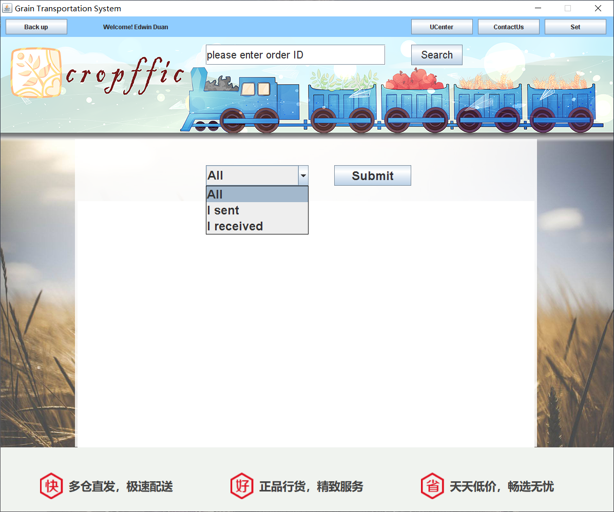

**The result of check**

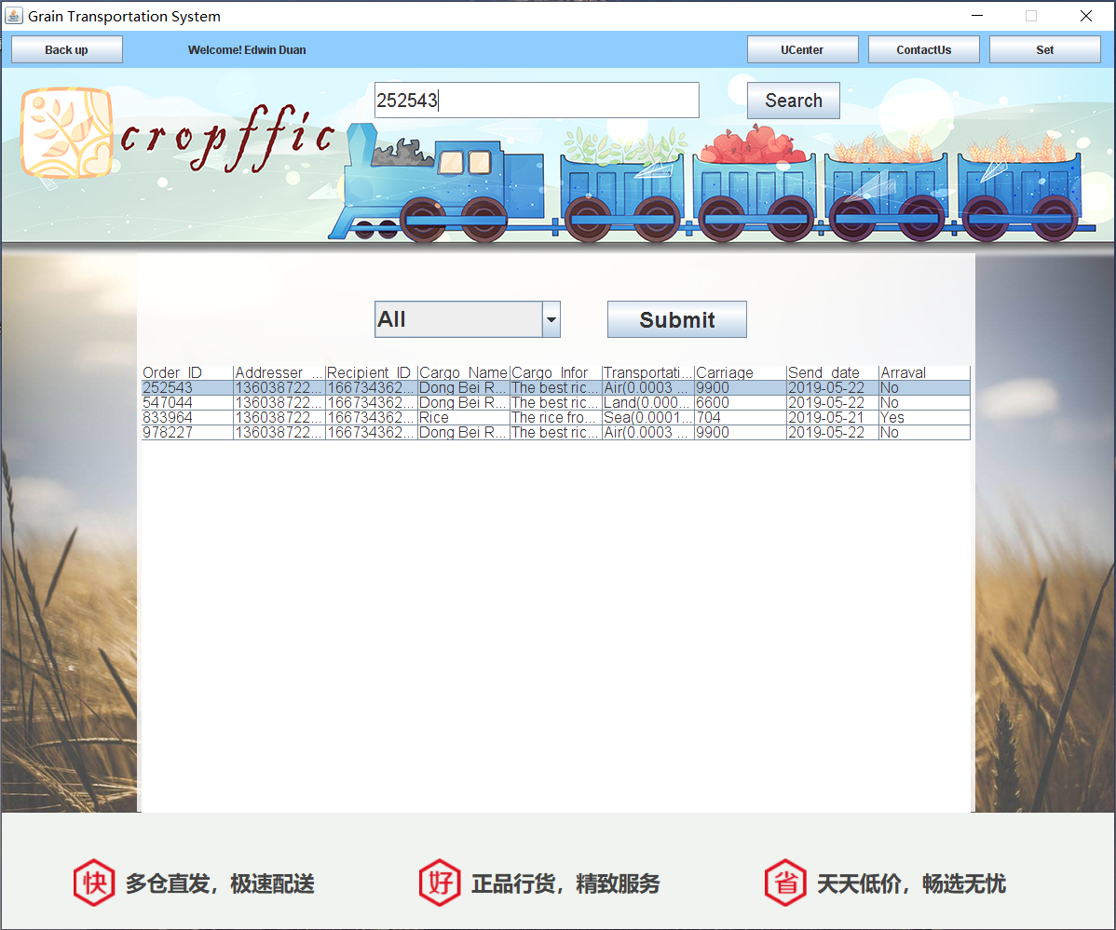

**Search the order by ID**

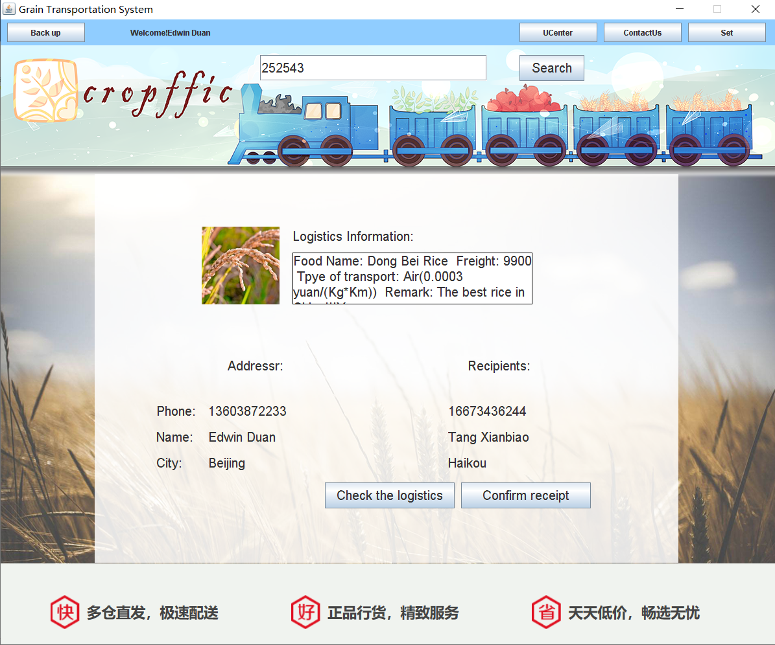

**Get.java**

package niitprojcet;

import java.sql.*;

import java.awt.Color;

import java.awt.Font;

import java.awt.event.ActionEvent;

import java.awt.event.ActionListener;

import java.awt.event.WindowAdapter;

import java.awt.event.WindowEvent;

import java.sql.Connection;

import java.sql.PreparedStatement;

import java.sql.ResultSet;

import java.sql.SQLException;

import java.util.ArrayList;

import java.util.List;

import java.util.logging.Level;

import java.util.logging.Logger;

import javax.swing.*;

import javax.swing.table.DefaultTableModel;

public class Get extends JFrame implements ActionListener {

public void GUI() {

Font font = new Font("Arial", Font.PLAIN, 20);

jcb = new JComboBox();

jcb.setBounds(250, 50, 200, 40);

jcb.setFont(new Font("Arial", Font.BOLD, 24));

jcb.addItem("All");

jcb.addItem("I sent");

jcb.addItem("I received");

jbSubmit = new JButton("Submit");

jbSubmit.setFont(new Font("Arial", Font.BOLD, 24));

jbSubmit.setBounds(500, 50, 150, 40);

jbSubmit.addActionListener(this);

jtInfo = new JTable();

jtInfo.setBounds(0, 120, 890, 480);

jtInfo.setFont(new Font("Arial", Font.PLAIN, 16));

jpMain = new JLayeredPane();

jpMain.setBounds(150, 200, 900, 600);

jpMain.add(jcb);

jpMain.add(jbSubmit);

jpMain.add(jtInfo);

jtfSearch = new JTextField();

jtfSearch.setFont(font);

jtfSearch.setBounds(400, 15, 350, 40);

jtfSearch.setText("please enter order ID");

jbSearch = new JButton("Search");

jbSearch.setFont(font);

jbSearch.setBounds(800, 15, 100, 40);

jbSearch.addActionListener(this);

jlGround = new JLabel();

jlGround.setBounds(0, 0, 1200, 800);

jlGround.setIcon(new ImageIcon(getClass().getResource("/pic/网页背景2.png")));

jlpBig = new JLayeredPane();

jlpBig.setLayout(null);

jlpBig.setBackground(Color.YELLOW);

jlpBig.setBounds(0, 40, 1200, 800);

jlpBig.add(jtfSearch);

jlpBig.add(jbSearch);

jlpBig.add(jpMain);

jlpBig.add(jlGround);

//下面一部分

jlDown = new JLabel();

jlDown.setIcon(new ImageIcon(getClass().getResource("/pic/Down.png")));

jlDown.setBounds(0, 0, 1200, 160);

jpDown = new JPanel();

jpDown.setLayout(null);

jpDown.setBounds(0, 840, 1200, 160);

jpDown.setBackground(Color.GREEN);

jpDown.add(jlDown);

//上面一部分

jbBack = new JButton("Back");

jbBack.setBounds(10, 5, 120, 30);

jbBack.addActionListener(this);

jlUserName = new JLabel("Welcome! " + Login.Name);

jlUserName.setBounds(200, 0, 250, 40);

jbUCenter = new JButton("UCenter");

jbUCenter.setBounds(800, 5, 120, 30);

jbUCenter.addActionListener(this);

jbContactUs = new JButton("ContactUs");

jbContactUs.setBounds(930, 5, 120, 30);

jbContactUs.addActionListener(this);

jbSet = new JButton("Set");

jbSet.setBounds(1060, 5, 120, 30);

jbSet.addActionListener(this);

jpUp = new JPanel();

jpUp.setLayout(null);

jpUp.setBounds(0, 0, 1200, 40);

jpUp.setBackground(new Color(144, 205, 255));

jpUp.add(jbBack);

jpUp.add(jbUCenter);

jpUp.add(jbSet);

jpUp.add(jbContactUs);

jpUp.add(jlUserName);

jf = new JFrame("Grain Transportation System");

jf.setDefaultCloseOperation(WindowConstants.DO_NOTHING_ON_CLOSE);

jf.addWindowListener(new WindowAdapter() {

@Override

public void windowClosing(WindowEvent e) {

int option = JOptionPane.showConfirmDialog(Get.this, "exit?", "提示", JOptionPane.YES_NO_OPTION);

if (option == JOptionPane.YES_OPTION) {

System.exit(0);

}

}

});

jf.setResizable(false);

jf.setSize(1200, 1000);

jf.setVisible(true);

jf.setLocationRelativeTo(null);

jf.setLayout(null);

jf.add(jpUp);

jf.add(jlpBig);

jf.add(jpDown);

}

public static void main(String[] args) {

new Get().GUI();

}

private JFrame jf;

private JPanel jpUp, jpDown;

private JLayeredPane jlpBig, jpMain;

private JButton jbUCenter, jbContactUs, jbSet, jbSearch, jbBack, jbSubmit;

private JLabel jlGround, jlUserName, jlDown;

private JTextField jtfSearch;

private JTable jtInfo;

private JComboBox jcb;

@Override

public void actionPerformed(ActionEvent e) {

if (e.getSource() == jbUCenter) {

// JOptionPane.showMessageDialog(jf, "This function is not currently on……");

Self_centery s = new Self_centery();

jf.dispose();

s.GUI();

}

if (e.getSource() == jbSet) {

JOptionPane.showMessageDialog(jf, "This function is not currently on……");

}

if (e.getSource() == jbBack) {

jf.dispose();

Main main = new Main();

main.GUI();

new Thread(main).start();

}

if (e.getSource() == jbContactUs) {

ContactUs contactUs = new ContactUs();

}

if (e.getSource() == jbSearch) {

if (jtfSearch.getText().length() > 0) {

Main.orderID = jtfSearch.getText();

Connection con = null;

PreparedStatement ps = null;

ResultSet rs = null;

try {

con = DBUtil.getConnection();

String sql = "select * from Order_forms where Order_id=?";

ps = con.prepareStatement(sql);

ps.setString(1, jtfSearch.getText());

rs = ps.executeQuery();

if (rs.next()) {

Main.HName = rs.getString(8);

Main.Info = rs.getString(9);

Main.ID1 = rs.getString(2);

Main.Name1 = rs.getString(3);

Main.City1 = rs.getString(4);

Main.ID2 = rs.getString(5);

Main.Name2 = rs.getString(6);

Main.City2 = rs.getString(7);

Main.Arr = rs.getString(13);

Main.Price = rs.getInt(11);

Main.Type = rs.getString(10);

Main.Flag = 1;

} else {

Main.Flag = 0;

}

sql = "select * from Citys where city_Name=?";

ps = con.prepareStatement(sql);

ps.setString(1, Main.City1);

rs = ps.executeQuery();

while (rs.next()) {

Main.X1 = rs.getInt(4);

Main.Y1 = rs.getInt(5);

}

sql = "select * from Citys where City_name=?";

ps = con.prepareStatement(sql);

ps.setString(1, Main.City2);

rs = ps.executeQuery();

while (rs.next()) {

Main.X2 = rs.getInt(4);

Main.Y2 = rs.getInt(5);

}

jf.dispose();

new Search().GUI();

} catch (SQLException ex) {

JOptionPane.showMessageDialog(jf, ex);

} finally {

try {

rs.close();

ps.close();

con.close();

} catch (SQLException ex) {

JOptionPane.showMessageDialog(jf, ex);

}

}

}

}

if (e.getSource() == jbSubmit) {

Connection con = null;

Statement st = null;

ResultSet rs = null;

try {

con = DBUtil.getConnection();

Object[] object;

String sql = null;

if (jcb.getSelectedIndex() == 0) {

sql = "select * from order_forms where Addresser_ID=" + Login.Phone + " or Recipient_ID=" + Login.Phone;

}

if (jcb.getSelectedIndex() == 1) {

sql = "select * from order_forms where Addresser_ID=" + Login.Phone;

}

if (jcb.getSelectedIndex() == 2) {

sql = "select * from order_forms where Recipient_ID=" + Login.Phone;

}

st = (Statement) con.createStatement();

rs = st.executeQuery(sql);

ResultSetMetaData rsmd = (ResultSetMetaData) rs.getMetaData();

int columnCount = rsmd.getColumnCount();

DefaultTableModel tm = (DefaultTableModel) jtInfo.getModel();

tm.setColumnCount(9);

tm.setRowCount(0);

object = new Object[9];

object[0] = (rsmd.getColumnName(1));

object[1] = (rsmd.getColumnName(2));

object[2] = (rsmd.getColumnName(5));

object[3] = (rsmd.getColumnName(8));

object[4] = (rsmd.getColumnName(9));

object[5] = (rsmd.getColumnName(10));

object[6] = (rsmd.getColumnName(11));

object[7] = (rsmd.getColumnName(12));

object[8] = (rsmd.getColumnName(13));

tm.addRow(object);

while (rs.next()) {

object[0] = (rs.getString(1));

object[1] = (rs.getLong(2));

object[2] = (rs.getLong(5));

object[3] = (rs.getString(8));

object[4] = (rs.getString(9));

object[5] = (rs.getString(10));

object[6] = (rs.getInt(11));

object[7] = (rs.getDate(12));

object[8] = (rs.getString(13));

tm.addRow(object);

}

tm.fireTableDataChanged();

} catch (Exception ex) {

JOptionPane.showMessageDialog(jf, ex);

} finally {

try {

rs.close();

st.close();

con.close();

} catch (SQLException ex) {

JOptionPane.showMessageDialog(jf, "Please enter the correct information");

}

}

}

}

}

**Search.java**

package niitprojcet;

import java.sql.*;

import java.awt.Color;

import java.awt.Font;

import java.awt.event.ActionEvent;

import java.awt.event.ActionListener;

import java.awt.event.WindowAdapter;

import java.awt.event.WindowEvent;

import java.sql.ResultSet;

import java.sql.SQLException;

import javax.swing.*;

public class Search extends JFrame implements ActionListener {

public void GUI() {

font = new Font("Arial", Font.PLAIN, 20);

jtfSearch = new JTextField();

jtfSearch.setFont(font);

jtfSearch.setBounds(400, 15, 350, 40);

jtfSearch.setText(Main.orderID);

jbSearch = new JButton("Search");

jbSearch.setFont(font);

jbSearch.setBounds(800, 15, 100, 40);

jbSearch.addActionListener(this);

jlTrip = new JLabel();

jlTrip.setBounds(250, 10, 400, 40);

jlTrip.setFont(new Font("Arial", Font.ITALIC, 26));

jlTrip.setForeground(Color.red);

jlPic1 = new JLabel();

jlPic1.setBounds(160, 80, 120, 120);

jlPic1.setIcon(new ImageIcon(getClass().getResource("/pic/p2.png")));

jlInfo = new JLabel("Logistics Information:");

jlInfo.setFont(font);

jlInfo.setBounds(300, 80, 230, 30);

jtaInfo = new JTextArea();

jtaInfo.setFont(font);

jtaInfo.setLineWrap(true);

jtaInfo.setWrapStyleWord(true);

jtaInfo.setBounds(300, 120, 370, 80);

jtaInfo.setEditable(false);

jtaInfo.setBorder(BorderFactory.createLineBorder(Color.BLACK));

jlAdr = new JLabel("Addressr:");

jlAdr.setFont(font);

jlAdr.setBounds(200, 280, 130, 30);

jlRec = new JLabel("Recipients:");

jlRec.setFont(font);

jlRec.setBounds(570, 280, 130, 30);

jlID = new JLabel("Phone:");

jlID.setFont(font);

jlID.setBounds(90, 350, 65, 30);

jlID1 = new JLabel();

jlID1.setFont(font);

jlID1.setBounds(170, 350, 220, 30);

jlID2 = new JLabel();

jlID2.setFont(font);

jlID2.setBounds(540, 350, 220, 30);

jlName = new JLabel("Name:");

jlName.setFont(font);

jlName.setBounds(90, 390, 60, 30);

jlName1 = new JLabel();

jlName1.setFont(font);

jlName1.setBounds(170, 390, 220, 30);

jlName2 = new JLabel();

jlName2.setFont(font);

jlName2.setBounds(540, 390, 220, 30);

jlCity = new JLabel("City:");

jlCity.setFont(font);

jlCity.setBounds(90, 430, 60, 30);

jlCity1 = new JLabel();

jlCity1.setFont(font);

jlCity1.setBounds(170, 430, 220, 30);

jlCity2 = new JLabel();

jlCity2.setFont(font);

jlCity2.setBounds(540, 430, 220, 30);

jb1 = new JButton("Check the logistics");

jb1.setFont(font);

jb1.setBounds(350, 475, 200, 40);

jb1.addActionListener(this);

jb2 = new JButton("Confirm receipt");

jb2.setFont(font);

jb2.setBounds(560, 475, 200, 40);

jb2.addActionListener(this);

jpMain = new JLayeredPane();

jpMain.setLayout(null);

jpMain.setBounds(150, 200, 900, 600);

jpMain.add(jlID);

jpMain.add(jlID1);

jpMain.add(jlID2);

jpMain.add(jlName);

jpMain.add(jlName1);

jpMain.add(jlName2);

jpMain.add(jlCity);

jpMain.add(jlCity1);

jpMain.add(jlCity2);

jpMain.add(jlAdr);

jpMain.add(jlRec);

jpMain.add(jlPic1);

jpMain.add(jlInfo);

jpMain.add(jtaInfo);

jpMain.add(jb1);

jpMain.add(jb2);

jpMain.add(jlTrip);

if (Main.Flag == 1) {

jtaInfo.setText("Food Name: " + Main.HName + " Freight: " + Main.Price + " Tpye of transport: " + Main.Type + " Remark: " + Main.Info);

jlID1.setText(Main.ID1);

jlID2.setText(Main.ID2);

jlName1.setText(Main.Name1);

jlName2.setText(Main.Name2);

jlCity1.setText(Main.City1);

jlCity2.setText(Main.City2);

}

if (Main.Flag == 0) {

jlTrip.setText("The order number does not exist !");

}

jlGround = new JLabel();

jlGround.setBounds(0, 0, 1200, 800);

jlGround.setIcon(new ImageIcon(getClass().getResource("/pic/网页背景2.png")));

jlpBig = new JLayeredPane();

jlpBig.setLayout(null);

jlpBig.setBackground(Color.YELLOW);

jlpBig.setBounds(0, 40, 1200, 800);

jlpBig.add(jtfSearch);

jlpBig.add(jbSearch);

jlpBig.add(jpMain);

jlpBig.add(jlGround);

//下面一部分

jlDown = new JLabel();

jlDown.setIcon(new ImageIcon(getClass().getResource("/pic/Down.png")));

jlDown.setBounds(0, 0, 1200, 160);

jpDown = new JPanel();

jpDown.setLayout(null);

jpDown.setBounds(0, 840, 1200, 160);

jpDown.setBackground(Color.GREEN);

jpDown.add(jlDown);

//上面一部分

jbBack = new JButton("Back");

jbBack.setBounds(10, 5, 120, 30);

jbBack.addActionListener(this);

jlUserName = new JLabel("Welcome!" + Login.Name);

jlUserName.setBounds(200, 0, 250, 40);

jbUCenter = new JButton("UCenter");

jbUCenter.setBounds(800, 5, 120, 30);

jbUCenter.addActionListener(this);

jbContactUs = new JButton("ContactUs");

jbContactUs.setBounds(930, 5, 120, 30);

jbContactUs.addActionListener(this);

jbSet = new JButton("Set");

jbSet.setBounds(1060, 5, 120, 30);

jbSet.addActionListener(this);

jpUp = new JPanel();

jpUp.setLayout(null);

jpUp.setBounds(0, 0, 1200, 40);

jpUp.setBackground(new Color(144, 205, 255));

jpUp.add(jbBack);

jpUp.add(jbUCenter);

jpUp.add(jbSet);

jpUp.add(jbContactUs);

jpUp.add(jlUserName);

jf = new JFrame("Grain Transportation System");

jf.setDefaultCloseOperation(WindowConstants.DO_NOTHING_ON_CLOSE);

jf.addWindowListener(new WindowAdapter() {

@Override

public void windowClosing(WindowEvent e) {

int option = JOptionPane.showConfirmDialog(Search.this, "exit?", "提示", JOptionPane.YES_NO_OPTION);

if (option == JOptionPane.YES_OPTION) {

System.exit(0);

}

}

});

jf.setResizable(false);

jf.setSize(1200, 1000);

jf.setVisible(true);

jf.setLocationRelativeTo(null);

jf.setLayout(null);

jf.add(jpUp);

jf.add(jlpBig);

jf.add(jpDown);

}

public static void main(String[] args) {

new Search().GUI();

}

private JFrame jf;

private JPanel jpUp, jpDown;

private JLayeredPane jlpBig, jpMain;

private JButton jbUCenter, jbContactUs, jbSet, jbSearch, jb1, jb2, jbBack;

private JLabel jlGround, jlUserName, jlDown, jlPic1, jlInfo, jlAdr, jlRec, jlTrip,

jlID, jlID1, jlID2, jlName, jlName1, jlName2, jlCity, jlCity1, jlCity2;

private JTextField jtfSearch;

private JTextArea jtaInfo;

private Font font;

public static int Flag = 0;

public static String Info;

public static String ID1;

public static String ID2;

public static String Name1;

public static String Name2;

public static String City1;

public static String City2;

public static String Arr;

@Override

public void actionPerformed(ActionEvent e) {

if (e.getSource() == jbUCenter) {

// JOptionPane.showMessageDialog(jf, "This function is not currently on……");

Self_centery s = new Self_centery();

jf.dispose();

s.GUI();

}

if (e.getSource() == jbSet) {

JOptionPane.showMessageDialog(jf, "This function is not currently on……");

}

if (e.getSource() == jbBack) {

jf.dispose();

Main main = new Main();

main.GUI();

new Thread(main).start();

}

if (e.getSource() == jbContactUs) {

ContactUs contactUs = new ContactUs();

}

if (e.getSource() == jbSearch) {

Connection con = null;

PreparedStatement ps = null;

ResultSet rs = null;

try {

con = (Connection) DBUtil.getConnection();

String sql = "select * from order_forms where Order_id=?";

ps = (PreparedStatement) con.prepareStatement(sql);

ps.setString(1, jtfSearch.getText());

Main.orderID = jtfSearch.getText();

rs = ps.executeQuery();

if (rs.next()) {

Main.HName = rs.getString(8);

Main.Info = rs.getString(9);

Main.ID1 = rs.getString(2);

Main.Name1 = rs.getString(3);

Main.City1 = rs.getString(4);

Main.ID2 = rs.getString(5);

Main.Name2 = rs.getString(6);

Main.City2 = rs.getString(7);

Main.Arr = rs.getString(13);

Main.Price = rs.getInt(11);

Main.Type = rs.getString(10);

Main.Flag = 1;

} else {

Main.Flag = 0;

}

sql = "select * from Citys where city_Neme=?";

ps = (PreparedStatement) con.prepareStatement(sql);

ps.setString(1, Main.City1);

rs = ps.executeQuery();

while (rs.next()) {

Main.X1 = rs.getInt(4);

Main.Y1 = rs.getInt(5);

}

sql = "select * from Citys where City_neme=?";

ps = (PreparedStatement) con.prepareStatement(sql);

ps.setString(1, Main.City2);

rs = ps.executeQuery();

while (rs.next()) {

Main.X2 = rs.getInt(4);

Main.Y2 = rs.getInt(5);

}

if (Main.Flag == 1) {

jtaInfo.setText("Food Name: " + Main.HName + " Freight: " + Main.Price + " Tpye of transport: " + Main.Type + " Remark: " + Main.Info);

jlID1.setText(Main.ID1);

jlID2.setText(Main.ID2);

jlName1.setText(Main.Name1);

jlName2.setText(Main.Name2);

jlCity1.setText(Main.City1);

jlCity2.setText(Main.City2);

jlTrip.setText("");

}

if (Main.Flag == 0) {

jlTrip.setText("The order number does not exist !");

jtaInfo.setText("");

jlID1.setText("");

jlID2.setText("");

jlName1.setText("");

jlName2.setText("");

jlCity1.setText("");

jlCity2.setText("");

}

} catch (SQLException ex) {

JOptionPane.showMessageDialog(jf, ex);

} finally {

try {

rs.close();

ps.close();

con.close();

} catch (SQLException ex) {

JOptionPane.showMessageDialog(jf, ex);

}

}

}

if (e.getSource() == jb2) {

if ("Yes".equalsIgnoreCase(Main.Arr)) {

JOptionPane.showMessageDialog(jf, "This order was recevied, do not confirm it again");

} else {

Receipt receipt = new Receipt();

}

}

if (e.getSource() == jb1) {

if ("Yes".equalsIgnoreCase(Main.Arr)) {

JOptionPane.showMessageDialog(jf, "This order was recevied");

} else {

jf.dispose();

Logistics l = new Logistics();

l.GUI();

new Thread(l).start();

}

}

}

}

**All the time goods GPS Location(Air Transportation)**



**All the time goods GPS Location(Land Transportation)**



**All the time goods GPS Location(Sea Transportation)**



**Enter User’s Password to receive the goods**

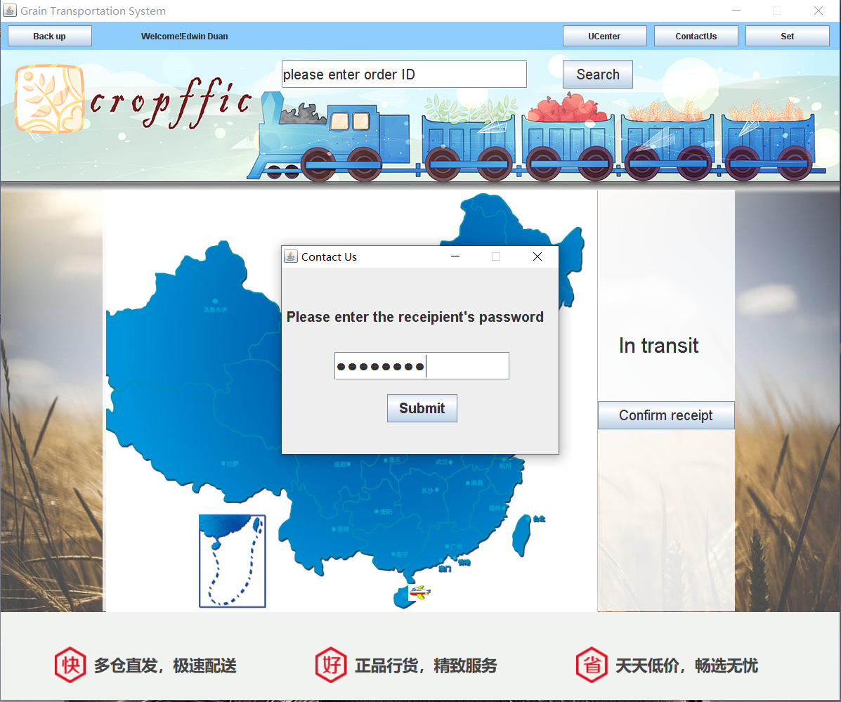

**Receive the goods Successfully**

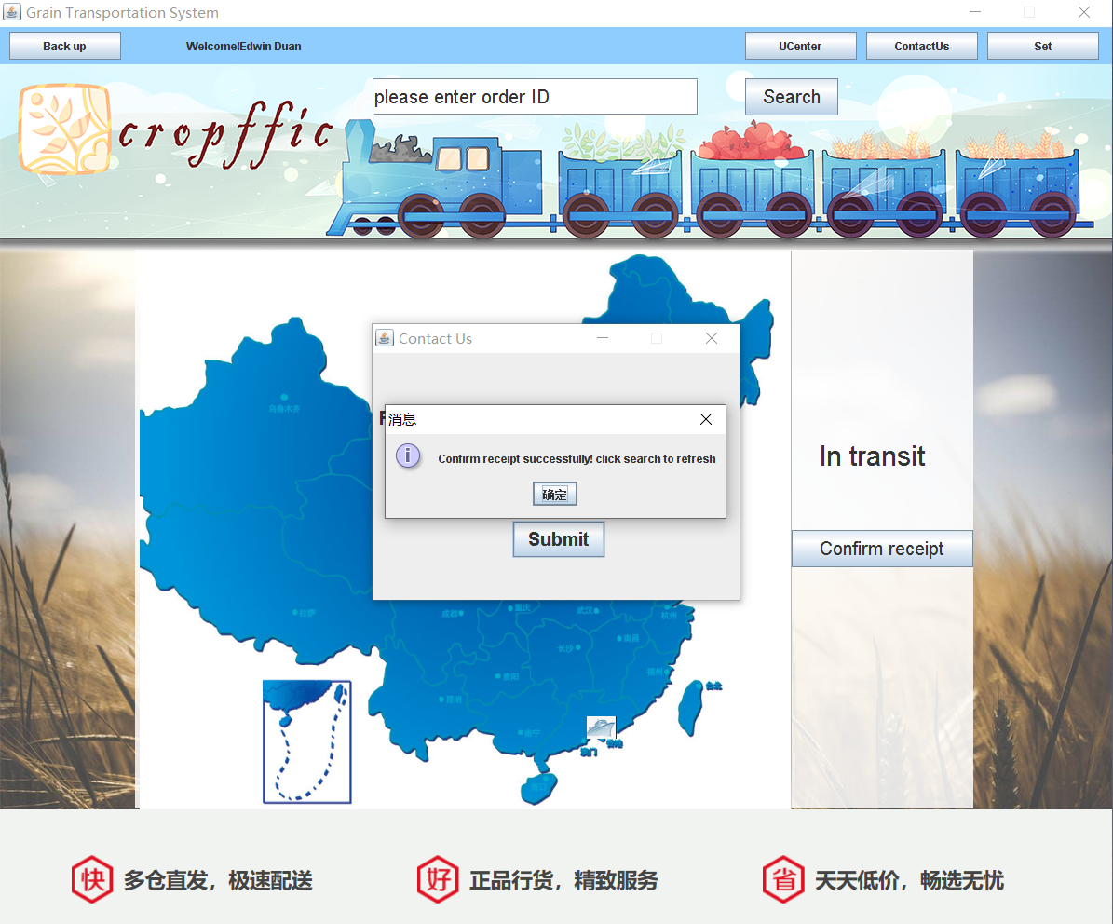

**Logistics.java**

package niitprojcet;

import java.awt.Color;

import java.awt.Font;

import java.awt.event.ActionEvent;

import java.awt.event.ActionListener;

import java.awt.event.WindowAdapter;

import java.awt.event.WindowEvent;

import java.sql.Connection;

import java.sql.PreparedStatement;

import java.sql.ResultSet;

import java.sql.SQLException;

import java.util.logging.Level;

import java.util.logging.Logger;

import javax.swing.*;

public class Logistics extends JFrame implements ActionListener, Runnable {

public void GUI() {

jlTran = new JLabel();

if ((Main.Type).equalsIgnoreCase("Sea(0.0001 yuan/(Kg*Km))")) {

jlTran.setIcon(new ImageIcon(getClass().getResource("/pic/pp2.png")));

}

else if ((Main.Type).equalsIgnoreCase("Land(0.0002 yuan/(Kg*Km))")) {

jlTran.setIcon(new ImageIcon(getClass().getResource("/pic/p3.png")));

}

else if ((Main.Type).equalsIgnoreCase("Air(0.0003 yuan/(Kg*Km))")) {

jlTran.setIcon(new ImageIcon(getClass().getResource("/pic/pp1.png")));

}

jlTran.setBounds(Main.X1, Main.Y1, 32, 24);

jl1 = new JLabel("●");

jl1.setBounds(Main.X1, Main.Y1, 12, 12);

jl1.setFont(new Font("宋体", Font.PLAIN, 12));

jl1.setForeground(Color.RED);

jl2 = new JLabel("●");

jl2.setBounds(Main.X2, Main.Y2, 12, 12);

jl2.setFont(new Font("宋体", Font.PLAIN, 12));

jl2.setForeground(Color.RED);

jlMap = new JLabel();

jlMap.setBounds(0, 0, 700, 600);

jlMap.setIcon(new ImageIcon(getClass().getResource("/pic/Map1.png")));

jlTrip = new JLabel("In transit");

jlTrip.setBounds(730, 200, 160, 40);

jlTrip.setFont(new Font("Arial", Font.PLAIN, 30));

jb = new JButton("Confirm receipt");

jb.setBounds(700, 300, 195, 40);

jb.setFont(new Font("Arial", Font.PLAIN, 20));

jb.addActionListener(this);

jlpMain = new JLayeredPane();

jlpMain.setLayout(null);

jlpMain.setBounds(150, 200, 900, 600);

jlpMain.add(jlTran);

jlpMain.add(jl1);

jlpMain.add(jl2);

jlpMain.add(jlMap);

jlpMain.add(jlTrip);

jlpMain.add(jb);

Font font = new Font("Arial", Font.PLAIN, 20);

jtfSearch = new JTextField();

jtfSearch.setFont(font);

jtfSearch.setBounds(400, 15, 350, 40);

jtfSearch.setText("please enter order ID");

jbSearch = new JButton("Search");

jbSearch.setFont(font);

jbSearch.setBounds(800, 15, 100, 40);

jbSearch.addActionListener(this);

jlGround = new JLabel();

jlGround.setBounds(0, 0, 1200, 800);

jlGround.setIcon(new ImageIcon(getClass().getResource("/pic/网页背景2.png")));

jlpBig = new JLayeredPane();

jlpBig.setLayout(null);

jlpBig.setBackground(Color.YELLOW);

jlpBig.setBounds(0, 40, 1200, 800);

jlpBig.add(jtfSearch);

jlpBig.add(jbSearch);

jlpBig.add(jlpMain);

jlpBig.add(jlGround);

//下面一部分

jlDown = new JLabel();

jlDown.setIcon(new ImageIcon(getClass().getResource("/pic/Down.png")));

jlDown.setBounds(0, 0, 1200, 160);

jpDown = new JPanel();

jpDown.setLayout(null);

jpDown.setBounds(0, 840, 1200, 160);

jpDown.setBackground(Color.GREEN);

jpDown.add(jlDown);

//上面一部分

jbBack = new JButton("Back up");

jbBack.setBounds(10, 5, 120, 30);

jbBack.addActionListener(this);

jlUserName = new JLabel("Welcome!" + Login.Name);

jlUserName.setBounds(200, 0, 250, 40);

jbUCenter = new JButton("UCenter");

jbUCenter.setBounds(800, 5, 120, 30);

jbContactUs = new JButton("ContactUs");

jbContactUs.setBounds(930, 5, 120, 30);

jbContactUs.addActionListener(this);

jbSet = new JButton("Set");

jbSet.setBounds(1060, 5, 120, 30);

jpUp = new JPanel();

jpUp.setLayout(null);

jpUp.setBounds(0, 0, 1200, 40);

jpUp.setBackground(new Color(144, 205, 255));

jpUp.add(jbBack);

jpUp.add(jbUCenter);

jpUp.add(jbSet);

jpUp.add(jbContactUs);

jpUp.add(jlUserName);

jf = new JFrame("Grain Transportation System");

jf.setDefaultCloseOperation(WindowConstants.DO_NOTHING_ON_CLOSE);

jf.addWindowListener(new WindowAdapter() {

@Override

public void windowClosing(WindowEvent e) {

int option = JOptionPane.showConfirmDialog(Logistics.this, "exit?", "提示", JOptionPane.YES_NO_OPTION);

if (option == JOptionPane.YES_OPTION) {

System.exit(0);

}

}

};

jf.setResizable(false);

jf.setSize(1200, 1000);

jf.setVisible(true);

jf.setLocationRelativeTo(null);

jf.setLayout(null);

jf.add(jpUp);

jf.add(jlpBig);

jf.add(jpDown);

}

public static void main(String[] args) {

Logistics l = new Logistics();

l.GUI();

new Thread(l).start();

}

private JFrame jf;

private JPanel jpUp, jpDown;

private JLayeredPane jlpBig, jlpMain;

private JButton jbUCenter, jbContactUs, jbSet, jbSearch, jbBack, jb;

private JLabel jlGround, jlUserName, jlDown, jlMap, jl1, jl2, jlTran, jlTrip;

private JTextField jtfSearch;

@Override

public void actionPerformed(ActionEvent e) {

if (e.getSource() == jb) {

if ("Yes".equalsIgnoreCase(Main.Arr)) {

JOptionPane.showMessageDialog(jf, "This order was recevied, do not confirm it again");

} else {

Receipt receipt = new Receipt();

}

}

if (e.getSource() == jbBack) {

jf.dispose();

new Search().GUI();

}

if (e.getSource() == jbContactUs) {

new ContactUs();

}

if (e.getSource() == jbSearch) {

if (jtfSearch.getText().length() > 0) {

Main.orderID = jtfSearch.getText();

Connection con = null;

PreparedStatement ps = null;

ResultSet rs = null;

try {

con = DBUtil.getConnection();

String sql = "select * from Order_forms where Order_id=?";

ps = con.prepareStatement(sql);

ps.setString(1, jtfSearch.getText());

rs = ps.executeQuery();

if (rs.next()) {

Main.HName = rs.getString(8);

Main.Info = rs.getString(9);

Main.ID1 = rs.getString(2);

Main.Name1 = rs.getString(3);

Main.City1 = rs.getString(4);

Main.ID2 = rs.getString(5);

Main.Name2 = rs.getString(6);

Main.City2 = rs.getString(7);

Main.Arr = rs.getString(13);

Main.Price = rs.getInt(11);

Main.Type = rs.getString(10);

Main.Flag = 1;

} else {

Main.Flag = 0;

}

sql = "select * from Citys where city_Name=?";

ps = con.prepareStatement(sql);

ps.setString(1, Main.City1);

rs = ps.executeQuery();

while (rs.next()) {

Main.X1 = rs.getInt(4);

Main.Y1 = rs.getInt(5);

}

sql = "select * from Citys where City_name=?";

ps = con.prepareStatement(sql);

ps.setString(1, Main.City2);

rs = ps.executeQuery();

while (rs.next()) {

Main.X2 = rs.getInt(4);

Main.Y2 = rs.getInt(5);

}

jf.dispose();

new Search().GUI();

} catch (SQLException ex) {

Logger.getLogger(Main.class.getName()).log(Level.SEVERE, null, ex);

} finally {

try {

rs.close();

ps.close();

con.close();

} catch (SQLException ex) {

Logger.getLogger(Main.class.getName()).log(Level.SEVERE, null, ex);

}

}

}

}}

@Override

public void run() {

int x = (Main.X2 - Main.X1) / 5;

int y = (Main.Y2 - Main.Y1) / 5;

try {

while (true) {

int x1 = Main.X1;

int y1 = Main.Y1;

jlTran.setBounds(x1, y1, 32, 24);

for (int i = 0; i <= 5; i++) {

x1 = x1 + x;

y1 = y1 + y;

if ((Main.Type).equalsIgnoreCase("Sea(0.0001 yuan/(Kg*Km))")) {

Thread.sleep(900);

jlTran.setBounds(x1, y1, 32, 24);

}

if ((Main.Type).equalsIgnoreCase("Land(0.0002 yuan/(Kg*Km))")) {

Thread.sleep(600);

jlTran.setBounds(x1, y1, 32, 24);

}

if ((Main.Type).equalsIgnoreCase("Air(0.0003 yuan/(Kg*Km))")) {

Thread.sleep(300);

jlTran.setBounds(x1, y1, 32, 24);

}

}

}

} catch (Exception ex1) {

JOptionPane.showMessageDialog(jf,ex1);

}

}

}

**Database Changed**

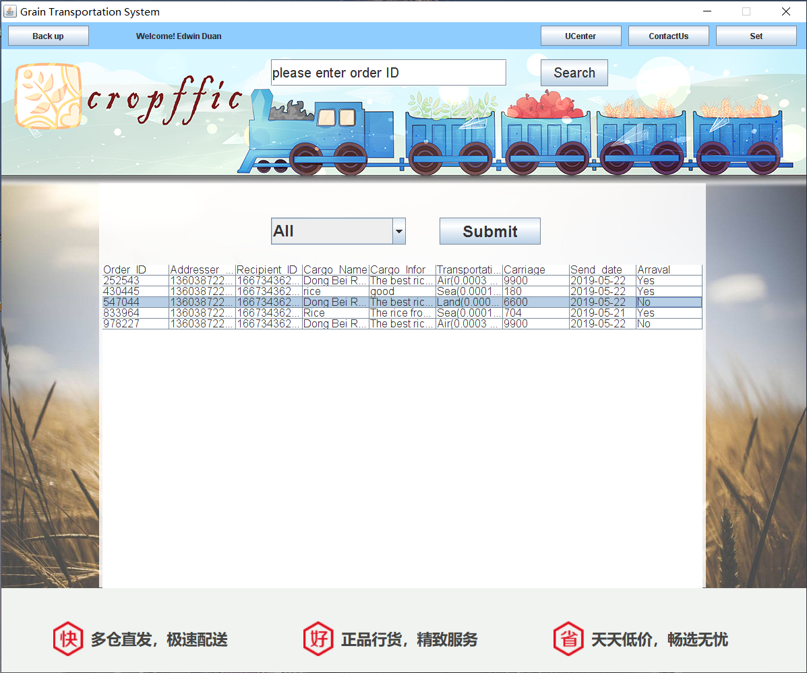

**Exit Moudle**

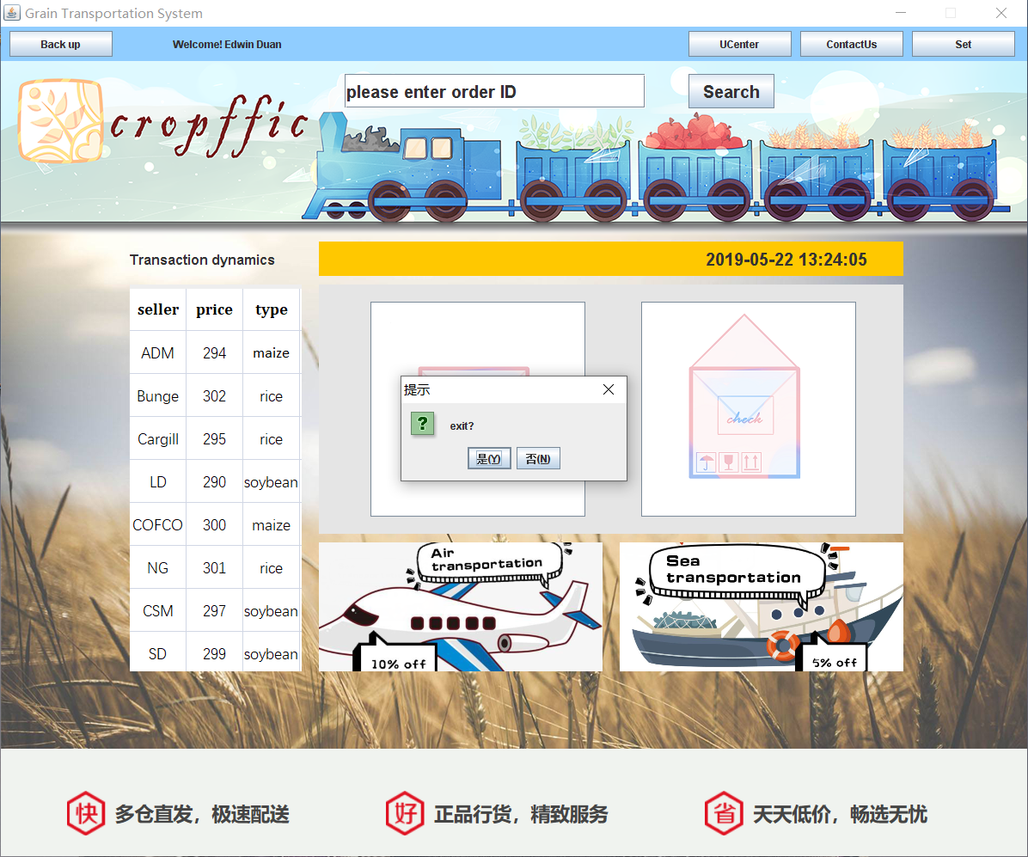

**Receipt.java**

package niitprojcet;

import java.awt.Font;

import java.awt.event.ActionEvent;

import java.awt.event.ActionListener;

import java.awt.event.WindowAdapter;

import java.awt.event.WindowEvent;

import javax.swing.*;

import javax.swing.WindowConstants;

import java.sql.*;

import java.util.logging.Level;

import java.util.logging.Logger;

public class Receipt extends JFrame implements ActionListener {

public Receipt() {

Font font = new Font("Arial", Font.BOLD, 20);

jl = new JLabel("Please enter the receipient's password");

jl.setBounds(7, 50, 385, 40);

jl.setFont(font);

jpf = new JPasswordField();

jpf.setBounds(75, 120, 250, 40);

jpf.setFont(new Font("a", Font.BOLD, 24));

jb = new JButton("Submit");

jb.setBounds(150, 180, 100, 40);

jb.setFont(font);

jb.addActionListener(this);

jp = new JPanel();

jp.setLayout(null);

jp.setBounds(0, 0, 400, 300);

jp.add(jl);

jp.add(jb);

jp.add(jpf);

jf = new JFrame("Contact Us");

jf.setDefaultCloseOperation(WindowConstants.DO_NOTHING_ON_CLOSE);

jf.addWindowListener(new WindowAdapter() {

@Override

public void windowClosing(WindowEvent e) {

int option = JOptionPane.showConfirmDialog(Receipt.this, "Cancel?", "提示", JOptionPane.YES_NO_OPTION);

if (option == JOptionPane.YES_OPTION) {

jf.dispose();

}

}

});

jf.setResizable(false);

jf.setSize(400, 300);

jf.setVisible(true);

jf.setLocationRelativeTo(null);

jf.setLayout(null);

jf.add(jp);

}

public static void main(String[] args) {

Receipt receipt = new Receipt();

}

private JFrame jf;

private JPanel jp;

private JLabel jl;

private JButton jb;

private JPasswordField jpf;

@Override

public void actionPerformed(ActionEvent e) {

if (e.getSource() == jb) {

Connection con = null;

PreparedStatement ps = null;

ResultSet rs = null;

try {

con = DBUtil.getConnection();

String sql = "select 1 from users where User_phone=? and user_password=?";

ps = con.prepareStatement(sql);

ps.setString(1, Main.ID2);

ps.setString(2, jpf.getText());

rs = ps.executeQuery();

if (rs.next()) {

sql = "update order_forms set Arraval='Yes' where order_ID=?";

System.out.println(Main.orderID);

ps = con.prepareStatement(sql);

ps.setString(1, Main.orderID);

ps.execute();

JOptionPane.showMessageDialog(jf, "Confirm receipt successfully! click search to refresh");

jf.dispose();

} else {

JOptionPane.showMessageDialog(jf, "Error Password");

}

} catch (SQLException ex) {

JOptionPane.showMessageDialog(jf, ex);

} finally {

try {

rs.close();

ps.close();

con.close();

} catch (SQLException ex) {

JOptionPane.showMessageDialog(jf, ex);

}

}

}

}

}